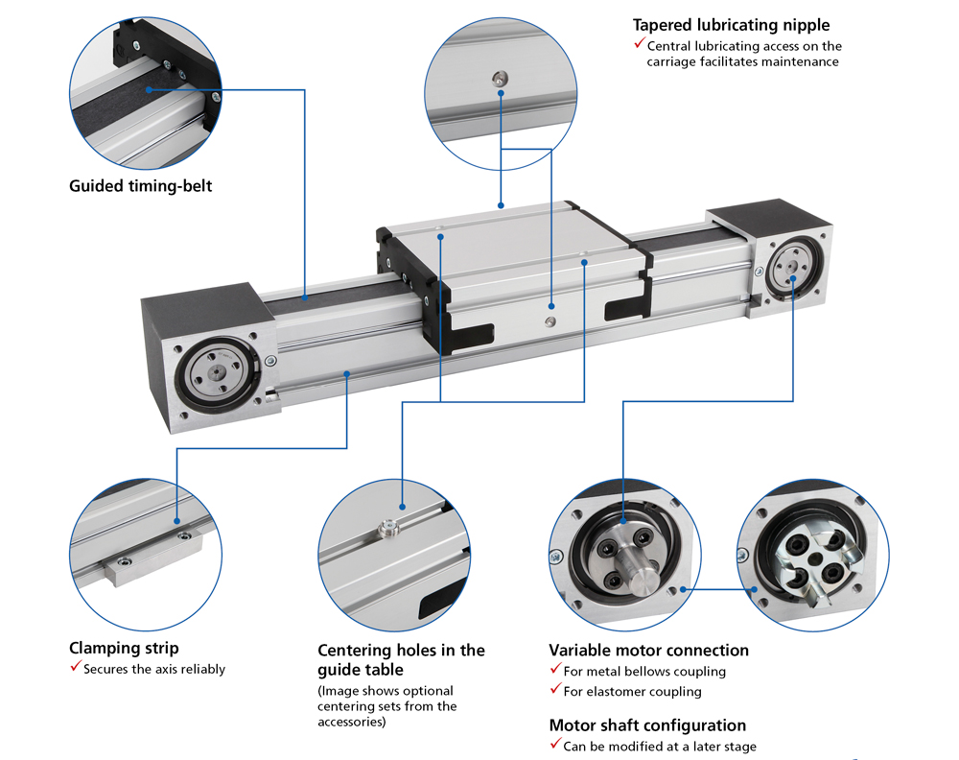
R+K Monoline Linear Unit
One of our most recent new products is the Monoline Linear Unit. The range is available in sizes 40, 60, 80 and 120 – either with a timing-belt drive (Z) or without a drive as anti-vibration torque support (R).
The size 40 timing belt driven version can withstand loads of up to 1100 N, the size 60 up to 2800 N, the size 80 can up to 4367 N and the 120 version can withstand loads of up to 9400 N. All units can reach travel speeds of up to 10 m/s, with permissible accelerations of up to 20 ms².
Clamping strips can be added for mounting and centering holes are added as standard to the guide table for accurate repeatability if a load is removed and returned.

RK Rose+Krieger
26 Faraday Road
Aylesbury
Buckinghamshire
HP19 8RY
01296 611660
rk@pmgb.co.uk
www.pmgb.co.uk/rk

