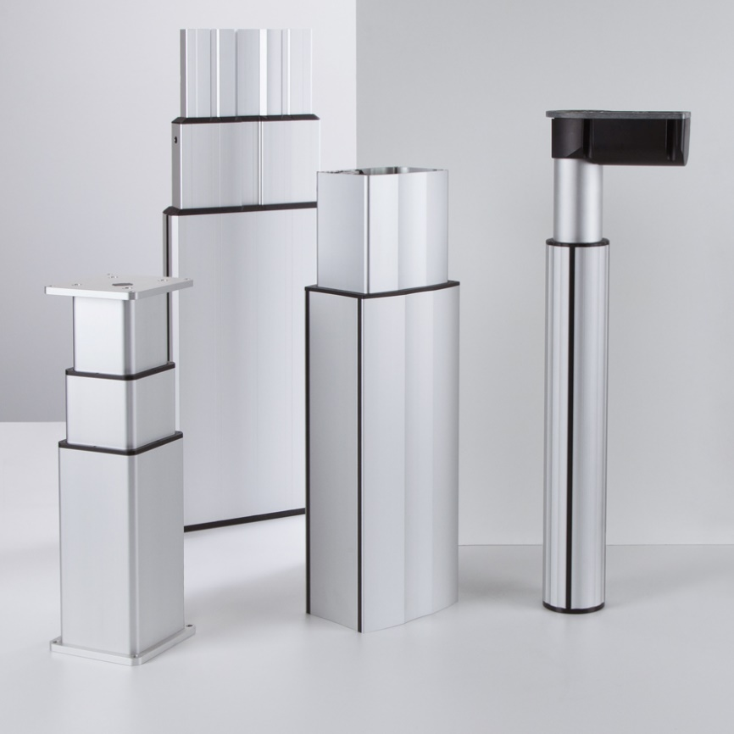
R+K Lifting Devices
R+K have a large range of lifting columns used for the raising and lowering of workbenches, conveyors, assembly stations, desks, in fact all kinds of applications. They can be operated singularly or in synchronised pairs. For more complex applications, several columns can be linked together via bus cables to enable more complicated applications to be realised.
They are operated via a handswitch plugged into a controller or via a customer sourced and programmed PLC.

RK Rose+Krieger
26 Faraday Road
Aylesbury
Buckinghamshire
HP19 8RY
01296 611660
rkgb@pmgb.co.uk
www.pmgb.co.uk/rk

