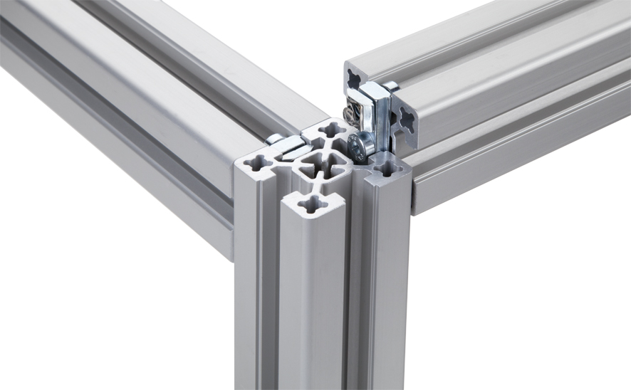
R+K Blocan aluminium profiles
Profiles from R+K are assembled without the need for preparatory machining. With our special connecting system, it’s possible to combine profiles from our range of over 100 sizes easily and securely saving time on assembly and installations.

The connecting system allows for maximum flexibility with ability to move and add lengths easily whilst also providing an incredibly strong and reliable fixation system. It is also designed so there can be no twist.

As expected with such a large range of profiles there is an even larger availability of accessories to realise your design ambitions.

RK Rose+Krieger
26 Faraday Road
Aylesbury
Buckinghamshire
HP19 8RY
01296 611660
rkgb@pmgb.co.uk
www.pmgb.co.uk/rk

