

Elesa launch high performance Misati pneumatic clamps for automation and robotics applications

**Press Release**

Misati Pneumatic Clamps available from Elesa UK


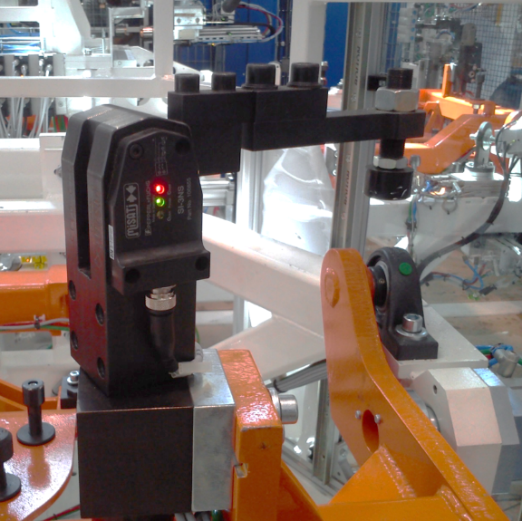

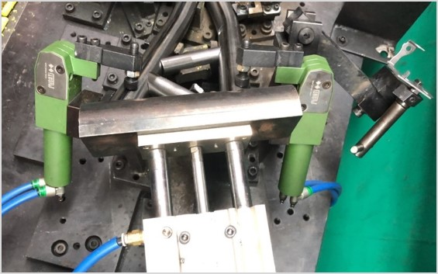

Elesa announce for this year a partnership with the well-known name of Misati, whose high-performance pneumatic clamps offer exceptional clamping action in work holding, or transport of assemblies in manufacturing operations. They are designed for robotic use, being easy to install, robust and well proven, with fast and reliable operation supported by simple power and control connections which enable rapid installation and setup. This easy installation with high quality design and manufacture is derived from wide experience of the industry and means that customers can quickly connect and go. Typical applications may be found in warehousing, welding stations, framing and assembly stations, special machines, tooling, jigs and fixture manufacture, dies and mould making.

Explained Nigel Pritchett, Elesa’s MD in the UK “The strong clamping action of the Misati range features mechanical interlock at closure with an integral non reversible ramp mechanism which takes over when the jaws are closed, this ensures that peak loads are directly transferred to the body structure of the clamp and not reliant on the pneumatic pressure.”

Pneumatic clamps from the range are specialised to match various industrial applications such as punching, welding, fastening/assembly and painting, with modular accessories that are convenient and readily interchangeable. These make fitting and adjustment straightforward, including gripper fingers for sheets or delicate materials, plus irregular shapes, hollow objects/tubes - also visually indicating open/closed/ready sensors. The choice of cylinders and matching accessories suit engineering industries such as automotive, rail, special vehicles, electronics and plastics production. They also work well in the wider fields of food processing, building construction, furniture manufacture, agriculture, chemical processing and pharmaceutical production as well as the medical industries and similar.

Misati pneumatic cylinders feature a double acting operation in diameters of 20mm, 32mm, 40mm and 50mm with three arm configurations dependent on the clamping arrangement required. The range is defined by high holding force, small size and reduced air consumption, plus a 7 year/20 Million cycle guarantee.

Further information regarding Elesa products may be found at: [www.elesa.com](http://www.elesa.com).