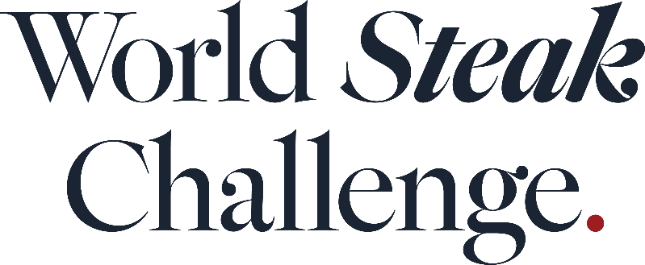

Australia reclaims the title of World’s Best Steak at 2026 World Steak Challenge

A fillet steak from Australia has been named as the World’s Best Steak following the results of the 2026 World Steak Challenge.

The steak, a Senku Pure Wagyu Fillet from Australian producer Paradigm Foods, was named at an award ceremony held in Amsterdam on 10 September following a judging day at Vlees & Co steakhouse in Amsterdam.

The winning steak was also named World's Best Grain Fed Fillet and Oceania’s Best Steak.

Australian producer Jack’s Creek & Albers, a previous winner of the World’s Best Steak category, took home the accolade of World’s Best Wagyu.

Other winners include Tesco Ireland, which won the award for World's Best Grass Fed Sirloin; LUMA Beef AG in the US, whose ribeye was named North America’s Best Steak; Ireland’s Dawn Meats, which won in the World's Best Grass Fed Ribeye category; and Chilean producer Agricola Mollendo S.A, which came top in the World's Best Grain Fed Sirloin category.

Steaks were awarded in both grain-fed and grass-fed categories. Awards were also handed out in two company categories - the Small Producer and Large Producer Awards. Toriyama Cattle Farm in Japan won the Small Producer Award and Australia’s Padoo Wagyu Corporation won the Large Producer Award.

A total of 328 medals were awarded at this year’s World Steak Challenge. Of the total, 128 were gold medals, 114 steaks were given silver medals, and 86 steaks were bronze medal winners.
Ireland took home the most gold medals, with 29 steaks from the country awarded the accolade, closely followed by Australia, with 27 steaks from the country awarded a gold medal. Overall, Ireland had the greatest medal haul with 82 steaks awarded either a gold, silver or bronze award, ahead of Australia with 42 medals, and England with 26 medals.
Judging for this year’s World Steak Challenge took place at premium steakhouse Vlees & Co in Amsterdam with more than 450 steaks judged blind by a carefully selected judging panel of more than 60 experts.
Judges included Richie Wilson, culinary director of FIRE Steakhouse & Bar; Ioannis Grammenos, executive chef and Meatologist of Heliot Steak House in London; Katie Doherty, CEO at the International Meat Trade Association; butcher and food writer Jessica Wragg; and Fred Smith, head of beef at Flat Iron.
“The World Steak Challenge once again shows the incredible quality of steaks that are being produced across the world with the utmost care and dedication to taste and animal husbandry,” says Stefan Chomka, editor of Restaurant.
“The challenge is a celebration of beef farming on a global scale and shines the spotlight on those farmers and producers at the very top of their game.
“Congratulations to every producer that received a medal at this year’s event.”
The World Steak Challenge is an annual event that gives steak producers and suppliers a much-needed platform to showcase product quality, breed credentials and processing standards on an international stage. It is organised by William Reed the publisher of Restaurant as well as a number of other leading business food and drink publications.
The World Steak Challenge is supported by partners Bord Bia and HVO Meat and is supported by Vlees & Co.

World Steak Challenge Full Winners List

World’s Best Steak
Senku Pure Wagyu, Paradigm Foods, Australia

Asia’s Best Steak
Japanese Black Wagyu, Meat Japan, Japan

North America’s Best Steak
Black Angus and Japanese Wagyu Ribeye, LUMA Beef AG, US

South America’s Best Steak
Angus Ribeye, MBRF | Fritz Fleisch & Fisch | Bēf&Co, Argentina

Oceania’s Best Steak
Purebred Wagyu Cross Fillet, Senku Pure Wagyu, Paradigm Foods, Australia

Europe’s Best Steak
Wagyu Cross Holstein Fillet, ABP UK, Northern Ireland

World’s Best Grain-Fed Sirloin
F1 Wagyu, Agricola Mollendo S.A, Chile

World’s Best Grain-Fed Ribeye
Japanese Black and Holstein Cross, Hasegawa Farm Co, Japan
World’s Best Grain-Fed Fillet
Senku Pure Wagyu, Paradigm Foods, Australia

World's Best Grass-Fed Sirloin
Angus Cross, Tesco Ireland, Ireland

World's Best Grass-Fed Ribeye
Aberdeen Angus Cross, Dawn Meats, Ireland

World’s Best Grass-Fed Fillet
Wagyu Cross Holstein, ABP UK, Northern Ireland

World’s Best Wagyu
Purebred Wagyu, Jack's Creek & Albers, Australia

Small Producer Award
Toriyama Cattle Farm, Japan

Large Producer Award.
Padoo Wagyu Corporation, Australia

Editor’s Notes

The World Steak Challenge is an annual event that gives steak producers and suppliers a much-needed platform to showcase product quality, breed credentials and processing standards on an international stage. It is organised by William Reed the publisher of Restaurant and a number of other leading business food and drink publications

The World Steak Challenge is held in Amsterdam and is judged by more than 60 judges from across the world. Judges this year included Richie Wilson, culinary director of FIRE Steakhouse & Bar; Ioannis Grammenos, executive chef and Meatologist of Heliot Steak House in London; Katie Doherty, CEO at the International Meat Trade Association; butcher and food writer Jessica Wragg; and Fred Smith, head of beef at Flat Iron.

