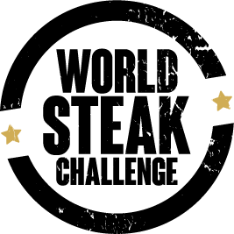

World Steak Challenge 2022 results revealed in Dublin
Ireland dominates with highest number of medals

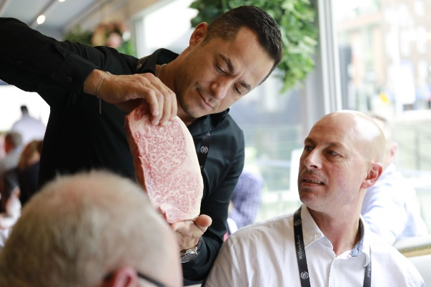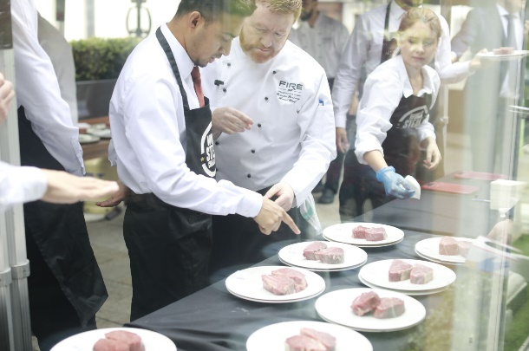
The 2022 World Steak Challenge results are hot off the grill following last night’s event at the Round Room at the Mansion House in Dublin. After a full day’s technical judging at FIRE Steakhouse & Bar, Ireland has had a sizzling success, taking a total of 54 medals, the most for any country involved this year. A gold medal was presented to a female 20-month Black Angus steak from Redmond Farm, Co Wexford. Raised on the farm with a free-range lifestyle, the winner was grass-fed and supplemented with an abundance of vegetables, making it rich in Omega 3, antioxidants and vitamin E which contributes to the marbling process. All these elements result in succulent, juicy flavours with a hint of earthiness from the land. The winning steak is available to buy online at Farmhouse Grocer. Also topping the list with gold medal wins for Ireland was James Whelan Butchers, Ashbourne Meat and several customers of ABP Ireland.

A Japanese Wagyu was crowned the overall winner of World’s Best Steak and achieving the World’s Best Sirloin and World’s Best Grain-Fed. A first-time entry from Japan, the winning melt in the mouth steak is an A4 grade, 30-month-old female from Starzen Co. Raised in the Kagoshima region with a warm climate and abundant water, this ‘Akune Gold’ is carefully cultivated resulting in the highest quality Wagyu steak. The World’s Best Rib-Eye went to Australia’s Jack’s Creek, previous 2021 Best Fillet, Best Rib-Eye and Grain-Fed winners. The 32-month-old pure bred Wagyu was grain fed and praised by judges for being tender, juicy and full of buttery flavour. The winning fillet steak was revealed as the MFC Carni female from Poland. Grain fed and obtained by a cross breed of Polish Holstein and Black Angus, the steak is well-known for its intense flavours, sweet aroma and unique tenderness. The Best Grass-Fed steak in the world went to a full bred Dexter from Linden Foods, Northern Ireland. Sold in M&S, this 30-day matured rib eye was described by judges as being very tender and rich.

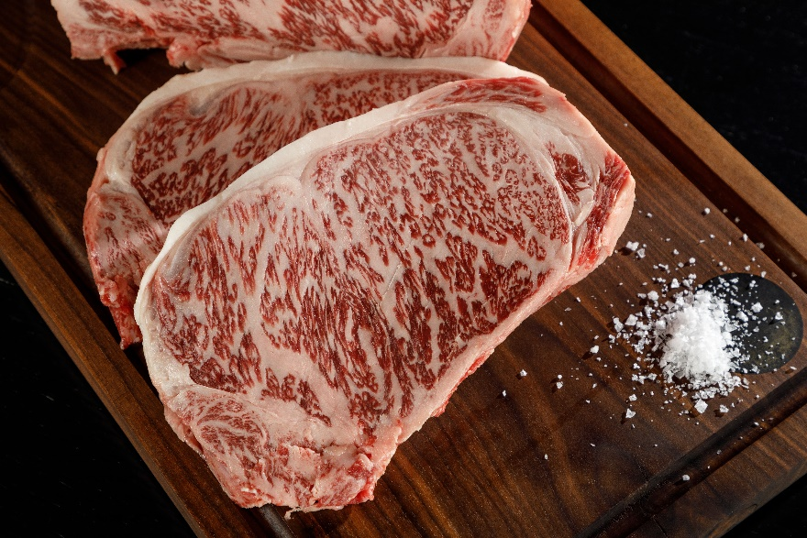
World’s Best Steak 2022 from Starzen Co, Japan.

This year’s competition was a sizzling success with gold, silver and bronze awards given to top steak producers and suppliers from around the world. Now in its 8th year, this year’s competition heated up with more entries than ever before, from over 20 different countries worldwide. Ireland celebrated after taking the most medals with a total of 54, followed by England with 36 and Finland with 28.
This year’s challenge took place in conjunction with the official host partner, Bord Bia, the judging partner, FIRE Steakhouse & Bar and the equipment partner, Synergy Grill Technology. The Synergy Grill is award-winning and ground-breaking technology of the perfect fuel-efficient burner to be used for the new generation of fat atomising gas grills, producing better quality food at lower energy costs than ever before. Developed in partnership with chefs over many years with particular emphasis on global development and sustainability and a focus on robustness and energy efficiency to meet today’s environmental goals. The Synergy Grill Technology is available to purchase at Brodericks, Dublin.

The awards were announced at the Round Room at the Mansion House in Dublin and were judged blind by a panel of over 60 independent experts including Richie Wilson, well-known TV chef and Culinary Director of FIRE Steakhouse & Bar and Ioannis Grammenos, Executive chef and Meatologist of Heliot Steak House in London.

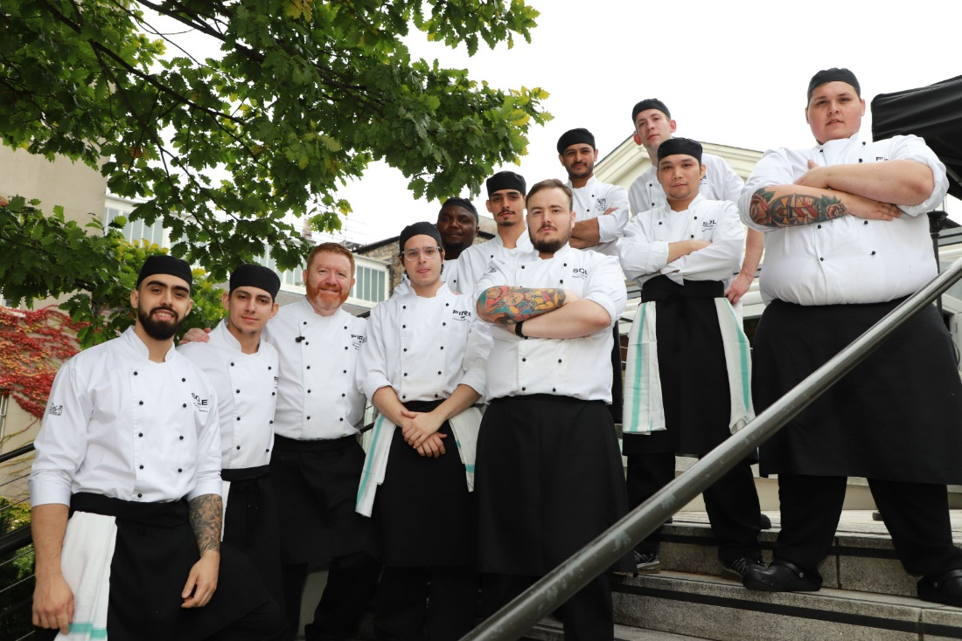
Mark Zieg, Beef Sector Manager at Bord Bia, said: “We are proud to welcome all the producers from around the world here to Ireland, where grass-fed and sustainable farming practices is core to our beef industry. We export 90% of our beef to over 50 markets around the world, even as far as Japan and the USA so it is very important to get our origin known and be recognised on the basis of quality and taste. In an environment like the World Steak Challenge with top producers, chefs and judges we feel it is the ideal opportunity to share our values in producing top quality beef.”
Richie Wilson, Culinary Director of FIRE Steakhouse, said: “It was a privilege to welcome the World Steak Challenge to Ireland and to have FIRE Steakhouse & Bar as the venue of choice for the 2022 judging process. To have the world's best beef cooked and served by our excellent team to a panel of industry experts was an absolute honour — a massive congratulations to all of the 2022 winners!”
www.worldsteakchallenge.com

Media enquiries:
Please contact Megan Pryor, Lorna Evans and Johara Chambers at Phipps Relations;
Worldsteakchallenge@thisisphipps.com

Notes to editors:
The World Steak Challenge winner's announcement took place on Wednesday the 28th of September at the Round Room at the Mansion House, Dublin.
THE WORLD STEAK CHALLENGE
The World Steak Challenge (WSC) gives steak producers and suppliers a much-needed platform to showcase product quality, breed credentials and processing standards on an international stage. The WSC is now in its eighth year and Irish food board, Bord Bia, is the official host partner.
The World Steak Challenge (WSC) is organised by William Reed the publisher behind the World’s 50 Best Restaurants and the International Wine Challenge, as well as leading business food and drink publications.

For more information visit:
Full results: World Steak Challenge 2022 - Winners
Instagram: @worldsteakchallenge
Twitter: @WSteakChallenge
Facebook: @WorldSteakChallenge
#WorldSteakChallenge

