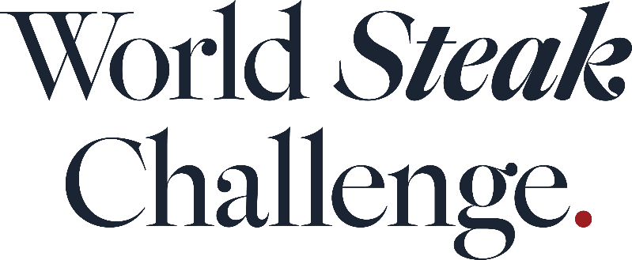

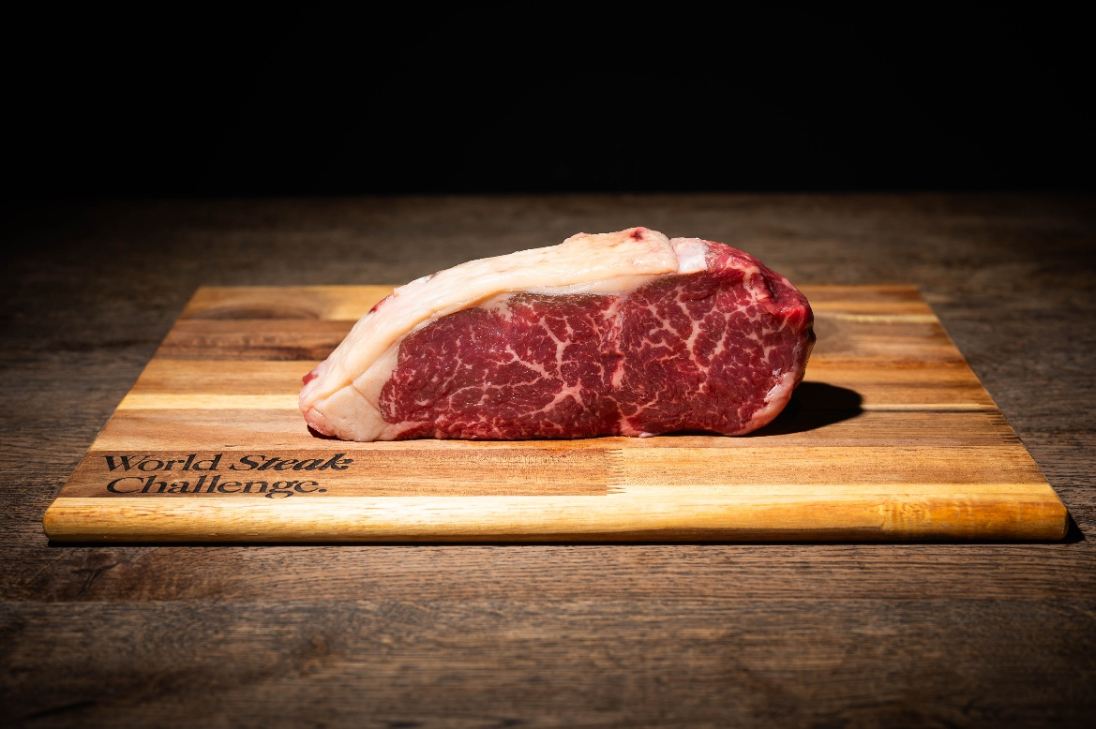

Download Winners Image Here

Ireland claims the title of World’s Best Steak at 2025 World Steak Challenge

A 32-day aged Irish angus striploin that is available in Lidl has been named as the World’s Best Steak following the results of the 2025 World Steak Challenge.

The steak, from producer Dawn Meats, was also named Europe’s Best Steak and the World's Best Grass-Fed Sirloin, at an award ceremony held in London on 10 November at steakhouse Smith & Wollensky following a two-day judging process in September at Vlees & Co steakhouse in Amsterdam.

Australian producer Jack’s Creek, a previous winner of the World’s Best Steak category, took home the accolade of Oceania’s Best Steak for its grain-fed pure bred wagyu sirloin, which was also named World’s Best Wagyu.

Other winners include Australia’s 2GR Wagyu Beef, which took home the award for World’s Best Grain-Fed Fillet; Fritz Fleisch & Fisch and Bēf&Co for a La Morocha rib-eye that was named South America’s Best Steak; and Meat Japan, whose Juku Japanese Mother Wagyu Striploin A4 was named Asia’s Best Steak.

Steaks were awarded in both grain-fed and grass-fed categories. Awards were also handed out in two company categories - the Small Producer and Large Producer Awards. Spanish producer Vacum Carnes de Lujo SL won the Small Producer Award and Japanese producer Arita Wagyu Co won the Large Producer Award.

A total of 304 medals were awarded at this year’s World Steak Challenge, which recognises the best quality meat across the globe. Of the total, 122 were gold medals, 109 steaks were given silver medals and 73 steaks bronze medals.

Australia once again took home the most gold medals, with 25 steaks from the country awarded the accolade, the most awarded to any country, closely followed by Ireland, with 24 steaks from the country awarded a gold medal. Overall, Ireland had the greatest medal haul with 68 steaks awarded either a gold, silver or bronze award, ahead of Australia with 40 medals and Argentina with 29 medals.

“This year’s winner shows that the best steaks can be available to everybody and the lengths that suppliers and retailers go to bring top quality beef to people’s tables,” says Restaurant editor Stefan Chomka. “Having a winning steak produced close to home is testament to the high quality of Irish beef and the country’s farming methods.”

“Bord Bia is delighted to sponsor the World Steak Challenge and to share with our industry partners what Irish beef farming has to offer, where grass-fed and sustainable farming practices is core to our beef industry,” says Bord Bia beef senior meat and livestock manager Joe Burke.

“Ireland exports 90% of our beef to over 50 markets around the world, from the US to the Philippines, which is a strong endorsement of the quality and reputation of Irish beef from farm to fork. We are thrilled that Ireland landed 62 medals in the competition. This is a means of having our origin known and be recognised internationally on the basis of quality and taste. Competitions like this provide an ideal opportunity to experience world class beef offerings and to also share our values in producing top quality beef with chefs and industry.”

The World Steak Challenge is supported by partner Bord Bia and is supported by Synergy Grill and Vlees & Co.

World Steak Challenge Full Winners List

World’s Best Steak
Irish Angus Striploin Steak – Lidl and Dawn Meats

Asia’s Best Steak
Juku Japanese Wagyu Striploin – Meat Japan

North America’s Best Steak
American Wagyu Sirloin – Barrett & Page

South America’s Best Steak
La Morocha Angus Rib Eye - Fritz Fleisch & Fisch, Bēf&Co

Oceania’s Best Steak
Australian Grain-fed Purebred Wagyu Sirloin - Jack’s Creek & Albers

Europe’s Best Steak
Irish Angus Striploin Steak – Lidl and Dawn Meats

World’s Best Grain-Fed Sirloin
Australian Wagyu Cross - Pardoo Wagyu Corporation

World’s Best Grain-Fed Ribeye
Polish Hereford Ribeye – Yes Butcher!

World’s Best Grain-Fed Fillet
Australian Eye Fillet – 2GR Wagyu Beef

World's Best Grass-Fed Sirloin
Irish Angus Striploin Steak – Lidl and Dawn Meats

World's Best Grass-Fed Ribeye
Premium Butcher Ribeye Wagyu Cross – Dawn Meats

World’s Best Grass-Fed Fillet
Sashi Fillet – JN Meat International

World’s Best Wagyu
Australian Grain-fed Purebred Wagyu Sirloin - Jack’s Creek & Albers

Small Producer Award
Vacum Carnes de Lujo

Large Producer Award
Arita Wagyu Co.

Editor’s Notes

The World Steak Challenge is an annual event that gives steak producers and suppliers a much-needed platform to showcase product quality, breed credentials and processing standards on an international stage. It is organised by William Reed the publisher of Restaurant as well as the World’s 50 Best Restaurants and a number of other leading business food and drink publications

The World Steak Challenge is judged by more than 60 judges from across the world. Judges this year included Richie Wilson, culinary director of FIRE Steakhouse & Bar; Ioannis Grammenos, executive chef and Meatologist of Heliot Steak House in London; Katie Doherty, CEO at the International Meat Trade Association; butcher and food writer Jessica Wragg; executive chef Luciana Berry, Fred Smith, head of beef at Flat Iron; and foodie Dimas Ramadhan.

PR to add details here.

