10% of UK Schools Are Using ProjectEVOLVE

As another school year goes past, we looked back on what changes had come about over the last year and how teachers throughout the UK responded to another difficult year in times of COVID. It was clear from 2020 that online safety had become a new priority for the UK and from what we saw throughout 2021, it seemed as though schools continued to spread awareness of this important topic to their students.
This became overwhelming apparent as our digital toolkit ProjectEVOLVE amassed an incredible amount of school support, with thousands of teachers throughout the UK signing up to get the latest educational guidance around online development for children and young people.
What Does the Data Show?
Since the free registration launched in Autumn last year, we have seen over 4000 organisations sign up and over 14,200 users actively using the material. If we break it down even further, that’s roughly over 1,200 new user accounts signing up each month. To put that into perspective, currently, 1/10 schools in the UK are currently using ProjectEVOLVE!
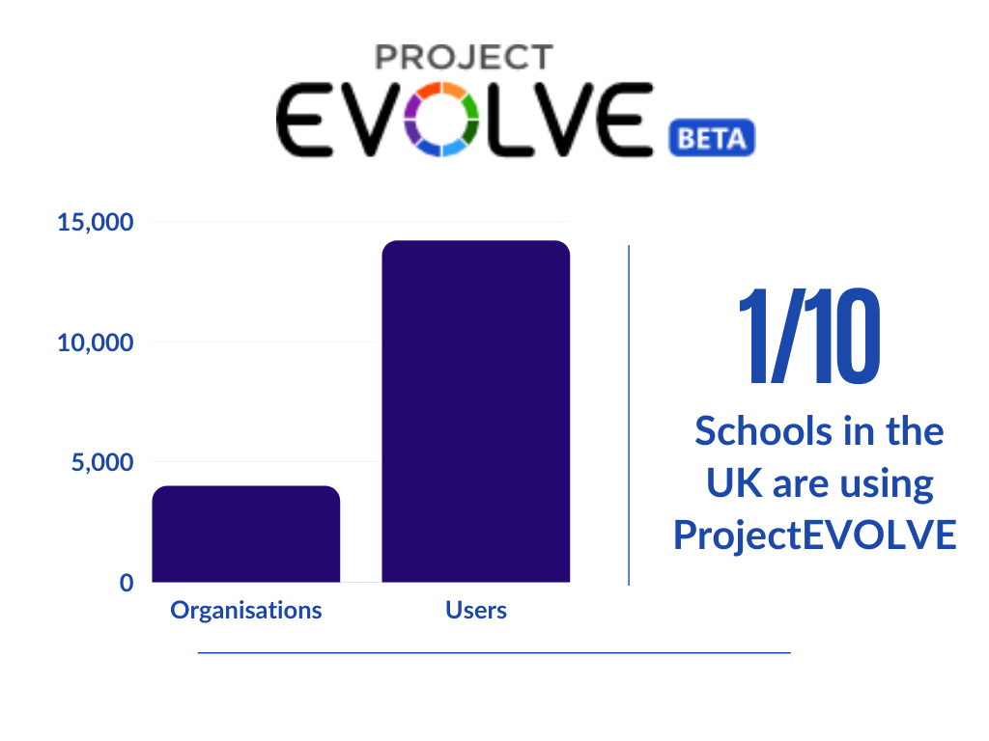
The overwhelming response has meant that professionals throughout the UK are better equipped to educate on essential steps forward in children and young peoples’ online development. As we have always said, the material is free to use and always will be. The guidance is available to anyone who wants to open active discussions with young people. From what we’ve seen so far, we hope the information will become a staple part of education for many years to come.
What Do the Professionals Think?
As part of our work, we are always looking to hear the feedback around the toolkit and how we can better it. Before the launch of the knowledge map tool, we piloted the new features with a group of professionals to see what they thought. As well as this, we actively open our channels to hear what others have to say. Take a look below:
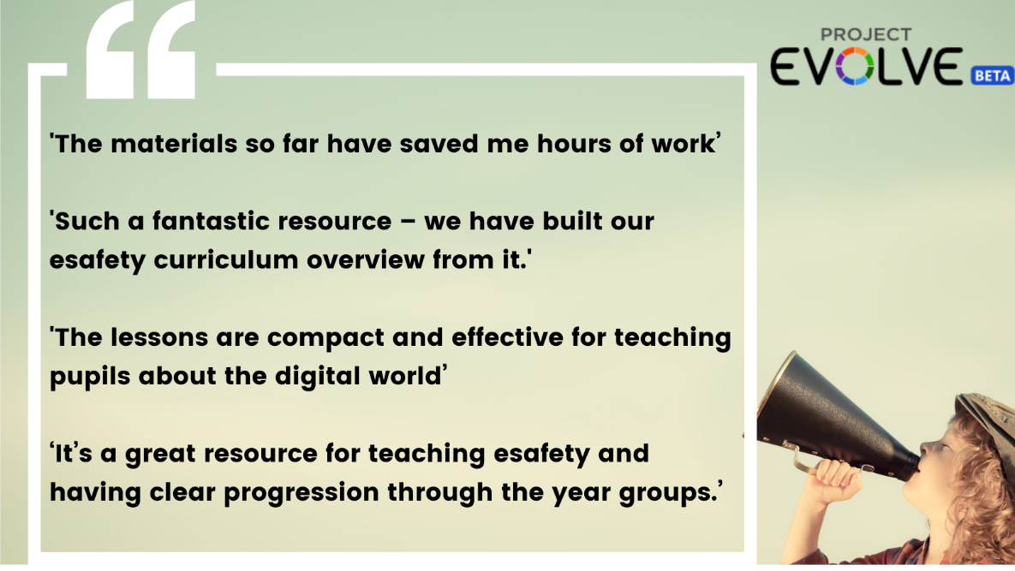

Planning for September
With the launch of the new knowledge features, professionals can now plan ahead for September to see how they can incorporate it into the new school year. The new analytics tools available can give valuable insight into where strengths and weaknesses lie in students’ online development.
Starting discussions in the classroom around common online situations can further develop their understanding of appropriate online behaviour. Use this time to get familiar with the tool so you can bring it into the classroom when the new school year starts.
ProjectEVOLVE Knowledge Maps

