‘Cora AI-powered Digital Assistant’
Supporting Material

Cora volumes in 2020
Week  Number | Date | Number of Cora conversations
11 | w/c 9th March 2020 | 113k
12 | w/c 15th March 2020 | 175k
13 | w/c 23rd March 2020 | 289k
14 | w/c 30th March 2020 | 300k
15 | w/c 6th April 2020 | 218k
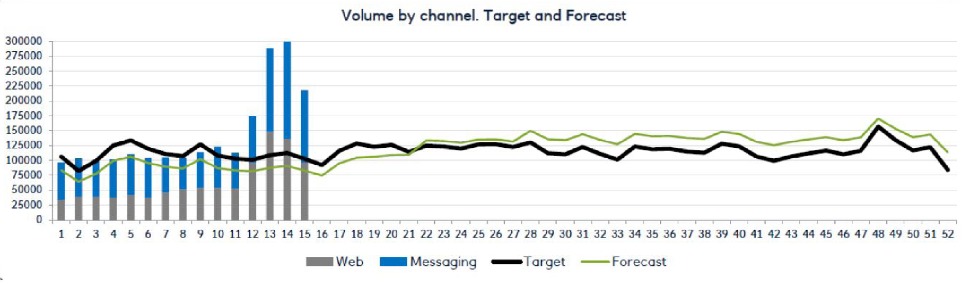

Cora Payment Holiday journey

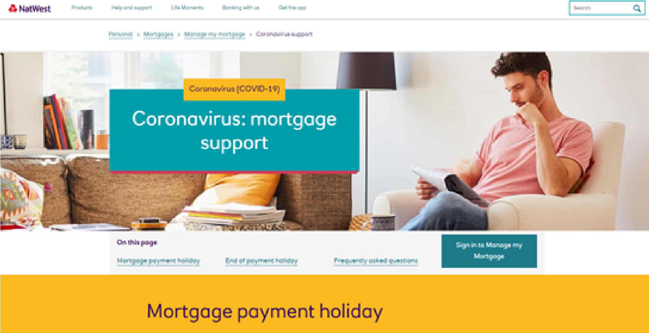
Customer inputs prompted by Cora:
- How long do you need the holiday for?
- When do you want it to start?
- How much can you afford to pay?
- Which account will the payment be taken from?
A bank colleague will read the conversation and put it into back-office. They will then send a message back to the customer confirmation that the payment holiday has been set up.
Cora will take the inputs and adds the conversation to the mortgage holiday queue.
Cora asks the customer whether Covid has impacted their ability to pay their mortgage?
Cora provides the customer with information about the payment holiday, which includes terms, credit scoring implications and arrears calculations.
YES
Mortgage payment holiday journey on mobile app and eBanking, guided by Cora:

