Welcome
Established in 1995, the AJ100 survey is the definitive annual record of the UK’s largest architecture practices measured by the number of architects employed in the UK.
The accompanying AJ100 awards programme celebrates the achievements of these firms, including those leading the way on sustainability.
AJ100 practices will be invited to attend the annual dinner, where the winners of the AJ100 awards will be revealed.
IMPORTANT - while it is possible to save your answers as you go along, once the survey has been completed and submitted, you will not be able to edit your submission. For easy reference to the survey questions, please find a PDF and Word version in the 'Resources' tab on the AJ100 website.
Section 1 - Practice Information
Please note -
while it is possible to save your answers as you go along, once the survey has been
completed and submitted, you will not be able to edit your submission. For easy reference to the
survey questions, please find a PDF and Word version in the 'Resources' tab on the AJ100 website.
1
.

Practice name

2
.

URL of practice

Full name
Email address
3
.

Who is the person to contact if there are any queries on your survey?

4
.

In which year was this architectural practice established?

Section 2 - Staff: number of architects and total staff
THIS SECTION IS MANDATORY
Please provide the number of qualified architects (both full-time & part-time, ARB registered or equivalent) permanently employed by your practice/company, according to the following categories. This includes any architects who qualified overseas.

Answer all questions below as of 31st December 2021
Please do not include architects on fixed-term contracts, short-term or long-term temporary staff, contractors or freelance staff
Do include architects who are partners if your practice is a partnership.
- Total number of all permanently employed qualified architects:
From the UK
From the EU
From the rest of the world
In the UK (ARB registered
or equivalent)
Overseas (ARB registered
or equivalent)
- Total number of qualified female architects permanently employed by your practice/company:
In the UK (ARB registered
or equivalent)
Overseas (ARB registered
or equivalent)
- Total number of qualified black, Asian, and minority ethnic architects permanently employed by your practice/company:
In the UK (ARB registered
or equivalent)
Overseas (ARB registered
or equivalent)
- Total number of (ARB registered or equivalent) qualified architects in your UK office who are:

Add explanation to the option(s) selected above:
9
.

Do you expect to increase or reduce staff levels of permanently employed architects (ARB registered or
equivalent) in the UK in 2022?
Please only select
ONE,
and explain why in the space below:

Increase in the UK
Decrease in the UK
Stay the same in the UK
Add explanation to the option(s) selected above:
10
.

Do you expect to increase or reduce staff levels of permanently employed architects (ARB registered
or equivalent) overseas in 2022?
Please only select
ONE
, and explain why in the space below:

Increase overseas
Decrease overseas
Stay the same overseas
No overseas offices
11
.
Total number of Part 1 architectural assistants (including Part 1 apprentices) you employ in the UK:

12
.

Total number of Part 2 architectural assistants (including Part 2 apprentices) you employ in the UK:

13
.

Total number of architectural apprentices you employ in the UK:

In the UK
Overseas
14
.

Total number of permanently-employed architectural staff including qualified architects, architectural
technologists, architectural assistants, model makers, visualisers, students etc. (do not include HR staff or
support staff):

In the UK
Overseas
15
.

Total number of people permanently employed (both full-time and part-time) in your company/practice
(
i.e. everyone in your company, including working partners, qualified architects, architectural staff,
engineers and general support staff):

In the UK
Overseas
16
.

Total number of fixed-term contract staff (i.e. not including permanent employees):

In the UK
Overseas
17
.

Total number of freelancers:

AJ100 Survey 2022
Section 3.1 - Architects by UK offices
Please provide the locations and postcodes of all your UK offices, as well as - for each office - the number of qualified architects, total number of architectural staff and the total number employed, including working partners and employees. Only include those who are permanently employed. The total number of architects in the UK offices should be the same as that stated in the first part of Q5.
Each box needs to be answered in order to process the question - you can simply answer "N/A" where it is not relevant to your practice. If you have more than three offices, please click 'yes' when prompted.
- Where is your first office located in the UK?
City
County
Postcode
Number of qualified
architects (including
working practice partners)
Total number of
architectural
staff (including architects)
Total number employed
- Where is your second office located in the UK?
(Enter N/A if not applicable)
City
County
Postcode
Number of qualified
architects (including
working practice partners)
Total number of
architectural
staff (including architects)
Total number employed
- Where is your third office located in the UK?
(Enter N/A if not applicable)
City
County
Postcode
Number of qualified
architects (including
working practice partners)
Total number of
architectural
staff (including architects)
Total number employed
- Do you have more than three offices?
Yes
No
AJ100 Survey 2022
- Where is your fourth office located in the UK?
City
County
Postcode
Number of qualified
architects (including
working practice partners)
Total number of
architectural
staff (including architects)
Total number employed
- Where is your fifth office located in the UK?
(Enter N/A if not applicable)
City
County
Postcode
Number of qualified
architects (including
working practice partners)
Total number of
architectural
staff (including architects)
Total number employed
- Where is your sixth office located in the UK?
(Enter N/A if not applicable)
City
County
Postcode
Number of qualified
architects (including
working practice partners)
Total number of
architectural
staff (including architects)
Total number employed
- Where is your seventh office located in the UK?
City
County
Postcode
Number of qualified
architects (including
working practice partners)
Total number of
architectural
staff (including architects)
Total number employed
(Enter N/A if not applicable)
City
County
Postcode
Number of qualified
architects (including
working practice partners)
Total number of
architectural
staff (including architects)
Total number employed
- Where is your eighth office located in the UK?
(Enter N/A if not applicable)
City
County
Postcode
Number of qualified
architects (including
working practice partners)
Total number of
architectural
staff (including architects)
Total number employed
27
.

Where is your ninth office located in the UK?
(
Enter N/A if not applicable
)

City
County
Postcode
Number of qualified
architects (including
working practice partners)
Total number of
architectural
staff (including architects)
Total number employed
28
.

Where is your tenth office located in the UK?
)
Enter N/A if not applicable
(

29
.

If you have any additional offices over 10, please enter the details below (Enter N/A if not applicable):

30. Have you closed any offices in the UK in 2021
Yes
No
31
.
Where were these now closed offices located in the UK?

32. Did you open any offices in the UK in 2021?
Yes
No
33
.
Where are these newly opened offices located in the UK?

34. Do you expect to close any offices in 2022?
Yes
No
35
.
Where do you expect to close these offices in the UK?

36. Do you expect to open any offices in 2022?
Yes
No
37
.
Where do you expect to open these offices in the UK?

Section 3.2 - Architects by International Regions
Please provide the location of any international offices.
For each office, please specify the number of qualified architects permanently employed (ARB or equivalent) and the total number of people employed, including working partners. The total number of architects in the international offices should be the same as that stated in the second part of question 5.
Each box needs to be answered in order to process the question. You can simply answer “N/A” where it is not relevant to your practice.
- Where is your first international office located?
City
Country
Number of qualified
architects (including
working practice partners)
Total number of
architectural staff
(
including architects
)
Total number employed
- Where is your second international office located?
City
Country
Number of qualified
architects (including
working practice partners)
Total number of
architectural
staff (including architects)
Total number employed
- Where is your third international office located??
City
Country
Number of qualified
architects (including
working practice partners)
Total number of
architectural staff
(
including architects
)
Total number employed
AJ100 Survey 2022
- Do you have more than three international offices?
Yes
No
AJ100 Survey 2022
- Where is your fourth international office located?
City
Country
Number of qualified
architects (including
working practice partners)
Total number of
architectural
staff (including architects)
Total number employed
- Where is your fifth international office located?
(enter N/A if not applicable)
City
Country
Number of qualified
architects (including
working practice partners)
Total number of
architectural
staff (including architects)
Total number employed
City
Country
Number of qualified
architects (including
working practice partners)
Total number of
architectural
staff (including architects)
Total number employed
- Where is your sixth international office located?
(enter N/A if not applicable)
- Where is your seventh international office located?
(enter N/A if not applicable)
City
Country
Number of qualified
architects (including
working practice partners)
Total number of
architectural staff
Total number employed
- Where is your eighth international office located?
(enter N/A if not applicable)
City
Country
Number of qualified
architects (including
working practice partners)
Total number of
architectural
staff (including architects)
Total number employed
- Where is your ninth international office located?
(enter N/A if not applicable)
City
Country
Number of qualified
architects (including
working practice partners)
Total number of
architectural
staff (including architects)
Total number employed
- Where is your tenth international office located?
(enter N/A if not applicable)
City
Country
Number of qualified
architects (including
working practice partners)
Total number of
architectural
staff (including architects)
Total number employed

- Did you close any international offices in 2021?
Yes
No
50
.
Where were these now closed international offices based?

51. Did you open any international offices in 2021?
Yes
No
52
.
Where have these international offices opened?

53. Do you expect to close any international offices in 2022?
Yes
No
54
.
Where do you expect to close these international offices?

55. Do you expect to open any international offices in 2022?
Yes
No
56
.
Where do you expect to open these international offices?

Section 4 - COVID-19 and BREXIT
Working entirely from
home (%)
Working from a
combination of home and
in your office(s) (%)
Working entirely from your
office (%)
Other (%) - please explain
in the following question
57
.

Part 1 of 2
Before the Government's announcement on December 8 2021 that it would be implementing Plan B in
response to rising Covid-19 infections, including working from home where possible, what approximate
proportion of your staff were?
58
.

Part 2 of 2: Please explain your answer to the previous question and clarify 'other' if used.

59
.

At the end of 2021, how does your overall productivity compare with that before the first national
lockdown in March 2020

Productivity is much higher than before March 2020
Productivity is slightly higher than before March 2020
Productivity is similar to that in March 2020
Productivity is slightly lower than in March 2020
Productivity is much lower than in March 2020
Most affected by the
Covid-19 crisis
Least affected by the
Covid-19 crisis
Were there any positives?
60
.

Please identify what aspects of your business were:

Please explain your answer
61
.

Following Brexit, to what extent have restrictions to the recruitment of EU architects and other skilled
architectural workers impacted on your business?

Not at all
Slightly
Substantially
Severely
Not relevant
Please explain your answer
62
.

How have your activities in the EU been affected by the UK leaving the EU?

We were not active in the EU market and are not expecting to be active in the EU market
We have ceased trading in the EU market
We have substantially reduced our business in the EU
Our EU business has remained roughly stable
We have increased business in the EU (includes entering the EU market)
We have substantially increased business in the EU
data.
Section 5.1 - Rewards, practice ownership and economic response
CONFIDENTIAL: The details of your practice will not be linked to the publication of the following
Partner/Director
Part III student
Year out student
63
.

Please indicate the average annual, full-time salary (excluding benefits/bonuses/commission) for the
following roles within your practice:
please answer without £, e.g.
(
10000)

64
.

Is your practice (choose one or multiple options)

A partnership
A limited liability partnership
A private limited company
A public limited company
Employee-owned
A co-operative
Other (please specify)
Associate
Architect
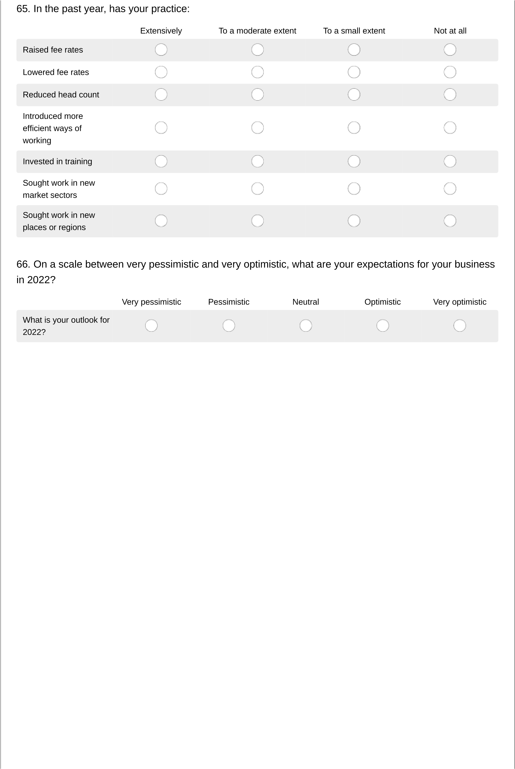

Section 5.2 - Employer of the Year Award
This award recognises the best practice for employees, judged on HR issues including staff satisfaction, workplace culture, benefits and staff turnover. This year we are particularly interested in how practices responded to the challenges of Covid-19, including the impact of both remote/hybrid working and the pandemic in general on staff wellbeing.
67. Would you like to enter the Employer of the Year Award?
Yes
No
AJ100 Survey 2022
68
.

Why do you think your practice should be considered for this award (300 words maximum)?
Practices need to submit an entry to show what initiatives have been put in place to help motivate and train
staff, and to promote staff wellbeing in general.

69
.

What career development strategy do you have for your employees? (300 words maximum)

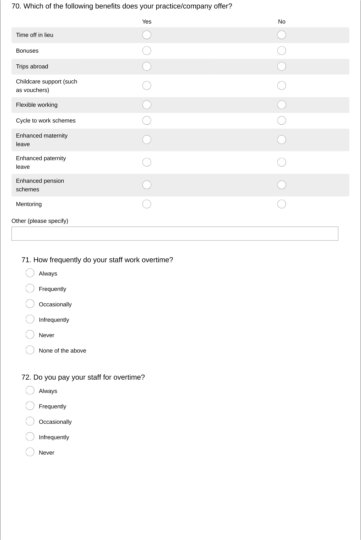
AJ100 Survey 2022
Section 6: Contract values
For both new build and refurbishment projects, and for a variety of contract values, please indicate the fees that you would typically charge on a project under both a traditional architectural contract and under a design and build contract.
We appreciate that this is very sensitive information and any information you provide will be treated as STRICTLY CONFIDENTIAL. Only average rates will be published for benchmarking purposes.
- New build: Please indicate your typical fee rates as a percentage of the following total construction costs when using different contracts/procurement means, or answer N/A if you are not active in that market.
Total contract value
£500,000 - Traditional
contract fee rate (%)
Total contract value
£500,000 - Design & Build
contract fee rate (%)
Total contract value £1
million - Traditional
contract fee rate (%)
Total contract value £1
million - Design & Build
contract fee rate (%)
Total contract value £2.5
million - Traditional
contract fee rate (%)
Total contract value £2.5
million - Design & Build
contract fee rate (%)
Total contract value £5
million - Traditional
contract fee rate (%)
Total contract value £5
million - Design & Build
contract fee rate (%)
Total contract value £10
million - Traditional
contract fee rate (%)
Total contract value £10
million - Design & Build
contract fee rate (%)
Total contract value £25
million - Traditional
contract fee rate (%)
Total contract value £25
million - Design & Build
contract fee rate (%)
Total contract value £50
£500,000 - Traditional
contract fee rate (%)
Total contract value
£500,000 - Design & Build
contract fee rate (%)
Total contract value £1
million - Traditional
contract fee rate (%)
Total contract value £1
million - Design & Build
contract fee rate (%)
Total contract value £2.5
million - Traditional
contract fee rate (%)
Total contract value £2.5
million - Design & Build
contract fee rate (%)
Total contract value £5
million - Traditional
contract fee rate (%)
Total contract value £5
million - Design & Build
contract fee rate (%)
Total contract value £10
million - Traditional
contract fee rate (%)
Total contract value £10
million - Design & Build
contract fee rate (%)
million - Traditional
contract fee rate (%)
Total contract value £50
million - Design & Build
contract fee rate (%)
Total contract value £100
million - Traditional
contract fee rate (%)
Total contract value £100
million - Design & Build
contract fee rate (%)
Total contract value £250
million - Traditional
contract fee rate (%)
Total contract value £250
million - Design & Build
contract fee rate (%)
- Refurbishment: Please indicate your typical fee rates as a percentage of the following total construction costs when using different contracts/procurement means, or answer N/A if you are not active in that market.
Total contract value
Total contract value £25
million - Traditional
contract fee rate (%)
Total contract value £25
million - Design & Build
contract fee rate (%)
Total contract value £50
million - Traditional
contract fee rate (%)
Total contract value £50
million - Design & Build
contract fee rate (%)
Total contract value £100
million - Traditional
contract fee rate (%)
Total contract value £100
million - Design & Build
contract fee rate (%)
Total contract value £250
million - Traditional
contract fee rate (%)
Total contract value £250
million - Design & Build
contract fee rate (%)

Section 7.1: Architectural fee income in the UK and overseas
THIS SECTION IS MANDATORY
With reference to your company/practice's architectural fees only (i.e. excluding fees earned for
engineering, surveying, planning etc.), and for the year to 31 December 2021, please provide the
income to your UK offices and to your overseas offices. Please provide this in UK Pound Sterling &
answer without the £ symbol e.g. 10000.
A. Architectural fee
income for buildings and
other projects located in
the UK (£)
B. Architectural fee
income for buildings and
other projects
located overseas (£)
C. Total architectural fee
income paid to your UK
offices £ (should be sum
of A & B).
75
.

For work managed and delivered out of your UK offices:

A. Architectural fee
income for buildings and
other projects located in
the UK (£)
B. Architectural fee
income for buildings and
other projects
located overseas (£)
C. Total architectural fee
income paid to your
overseas offices £ (should
be sum of A and B).
76
.

For work managed and delivered out of your overseas offices:

77
.

Grand total for architectural fee income to UK and overseas offices (£)

Section 7.2: Total income in the UK and overseas
THIS SECTION IS MANDATORY
With reference to your company /practice's total fee income (including architectural fees and fees
earned for engineering, surveying, planning, etc.), and for the year to 31 December 2021, please
provide the income to your UK offices and to your overseas offices.
Please provide this in UK Pound Sterling & answer without the £ symbol, e.g. 10000.
A. Total fee income for
buildings and other
projects located in the UK
(
£
)
B. Total fee income for
buildings and other
projects located overseas
(
£
)
C. Total fee income paid
to your UK offices £ (total
sum of A + C)
78
.

For work managed and delivered out of your UK offices:

A. Total fee income for
buildings and other
projects located in the UK
)
(
£
B. Total fee income for
buildings and other
projects located overseas
)
£
(
C. Total fee income paid
to your overseas offices £
(
).
total sum of A and B
79
.

For work managed and delivered out of your overseas offices:

80
.

Grand total for total fee income to UK and overseas offices (£).

Section 8: Working and seeking work abroad
81. Does your practice proactively seek work abroad?
('No' indicates that any overseas work is due to clients finding and selecting your practice)
Yes
No

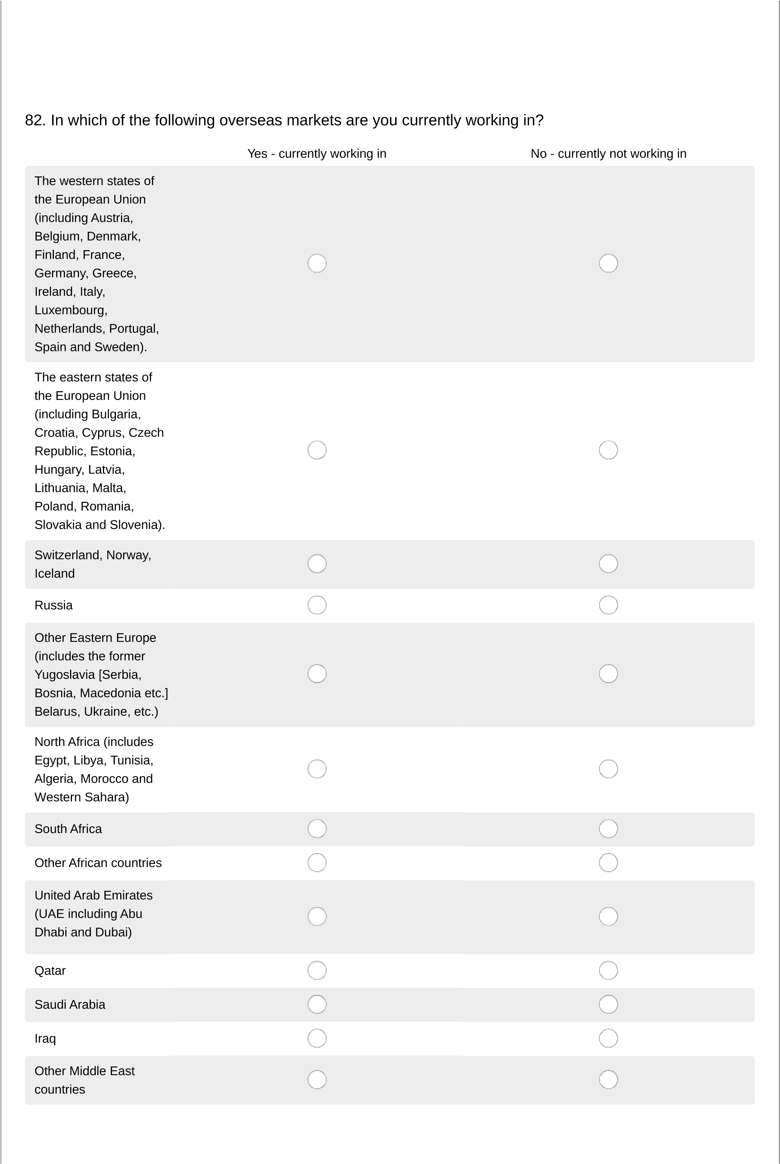
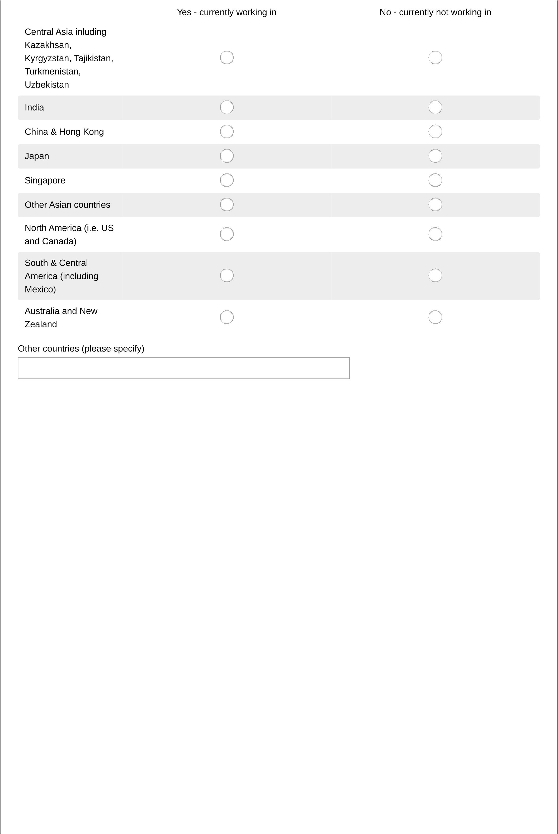
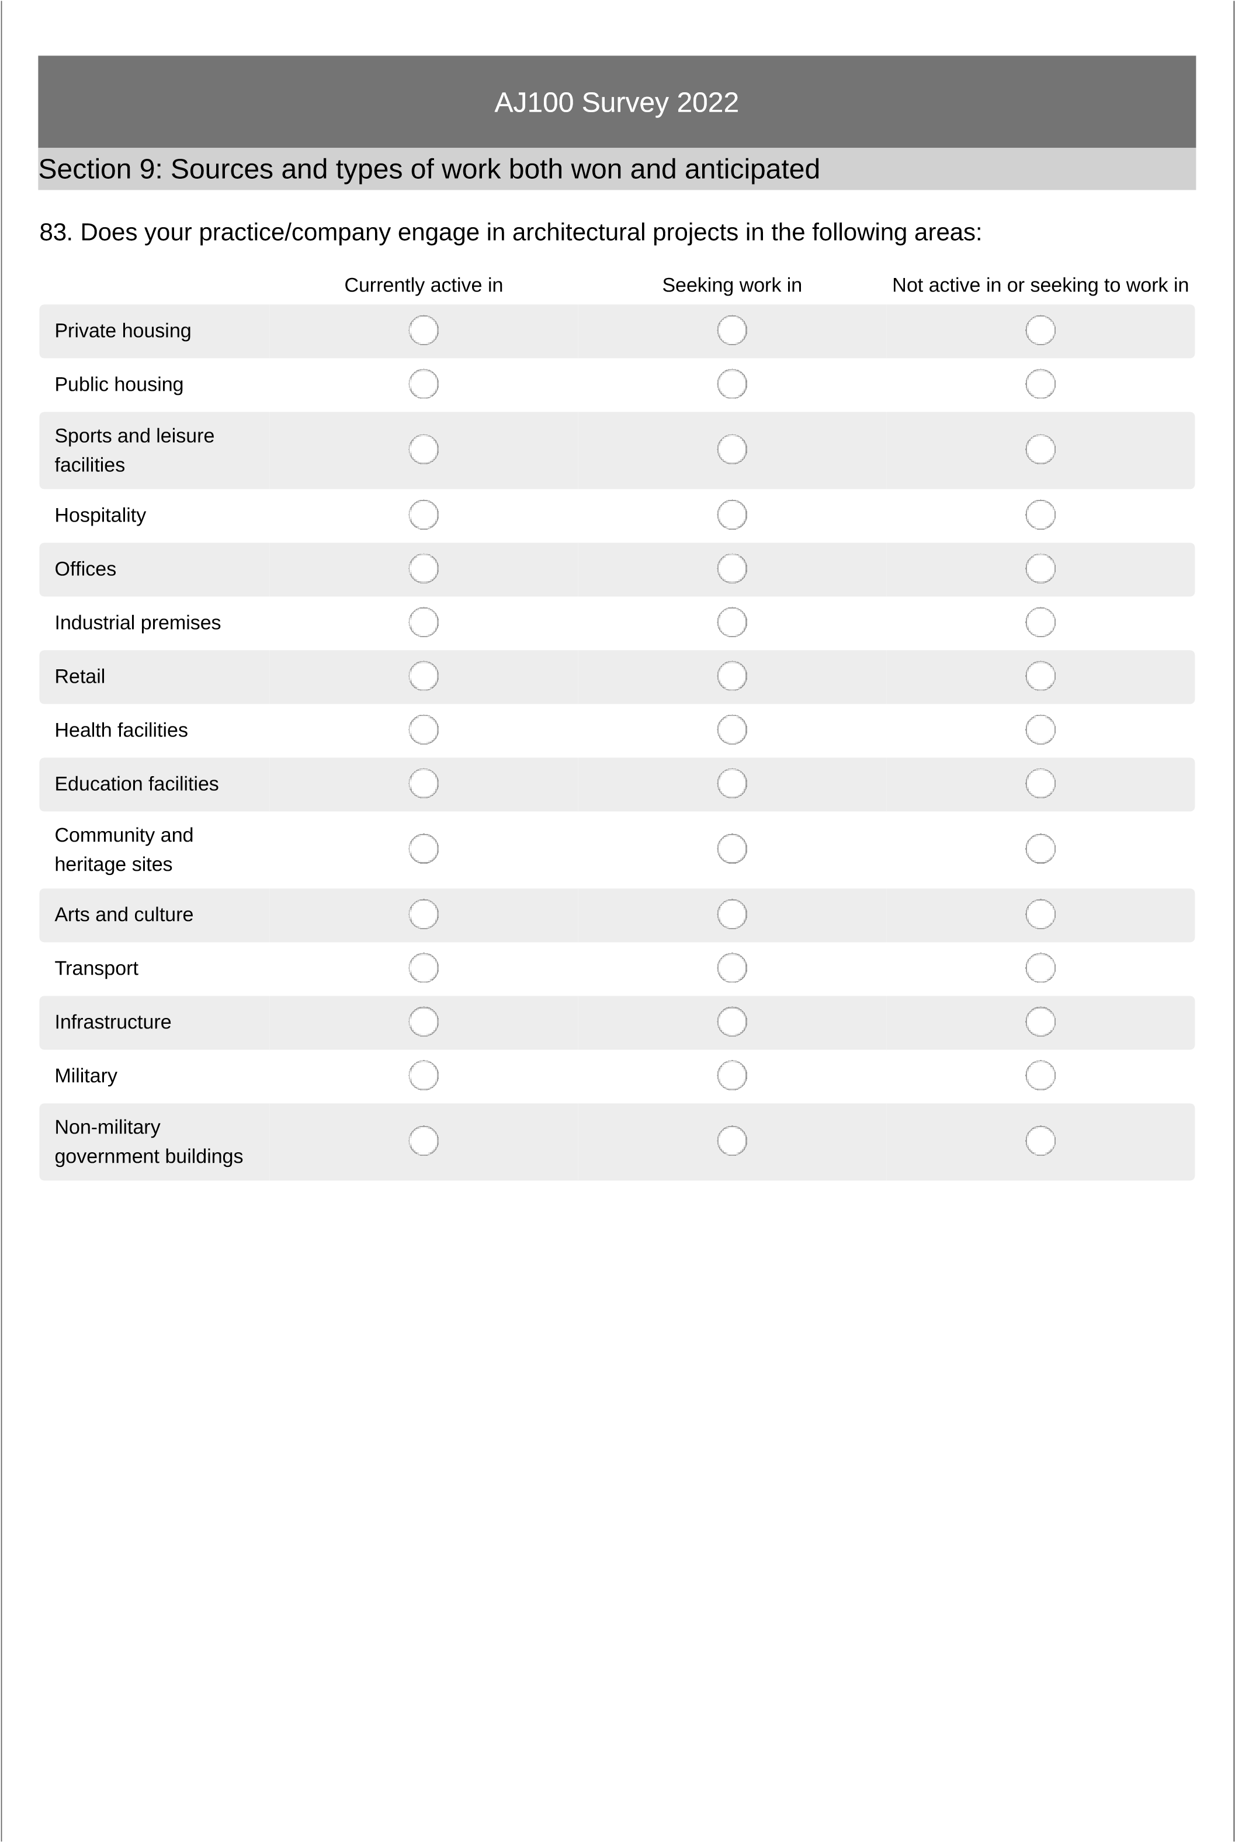
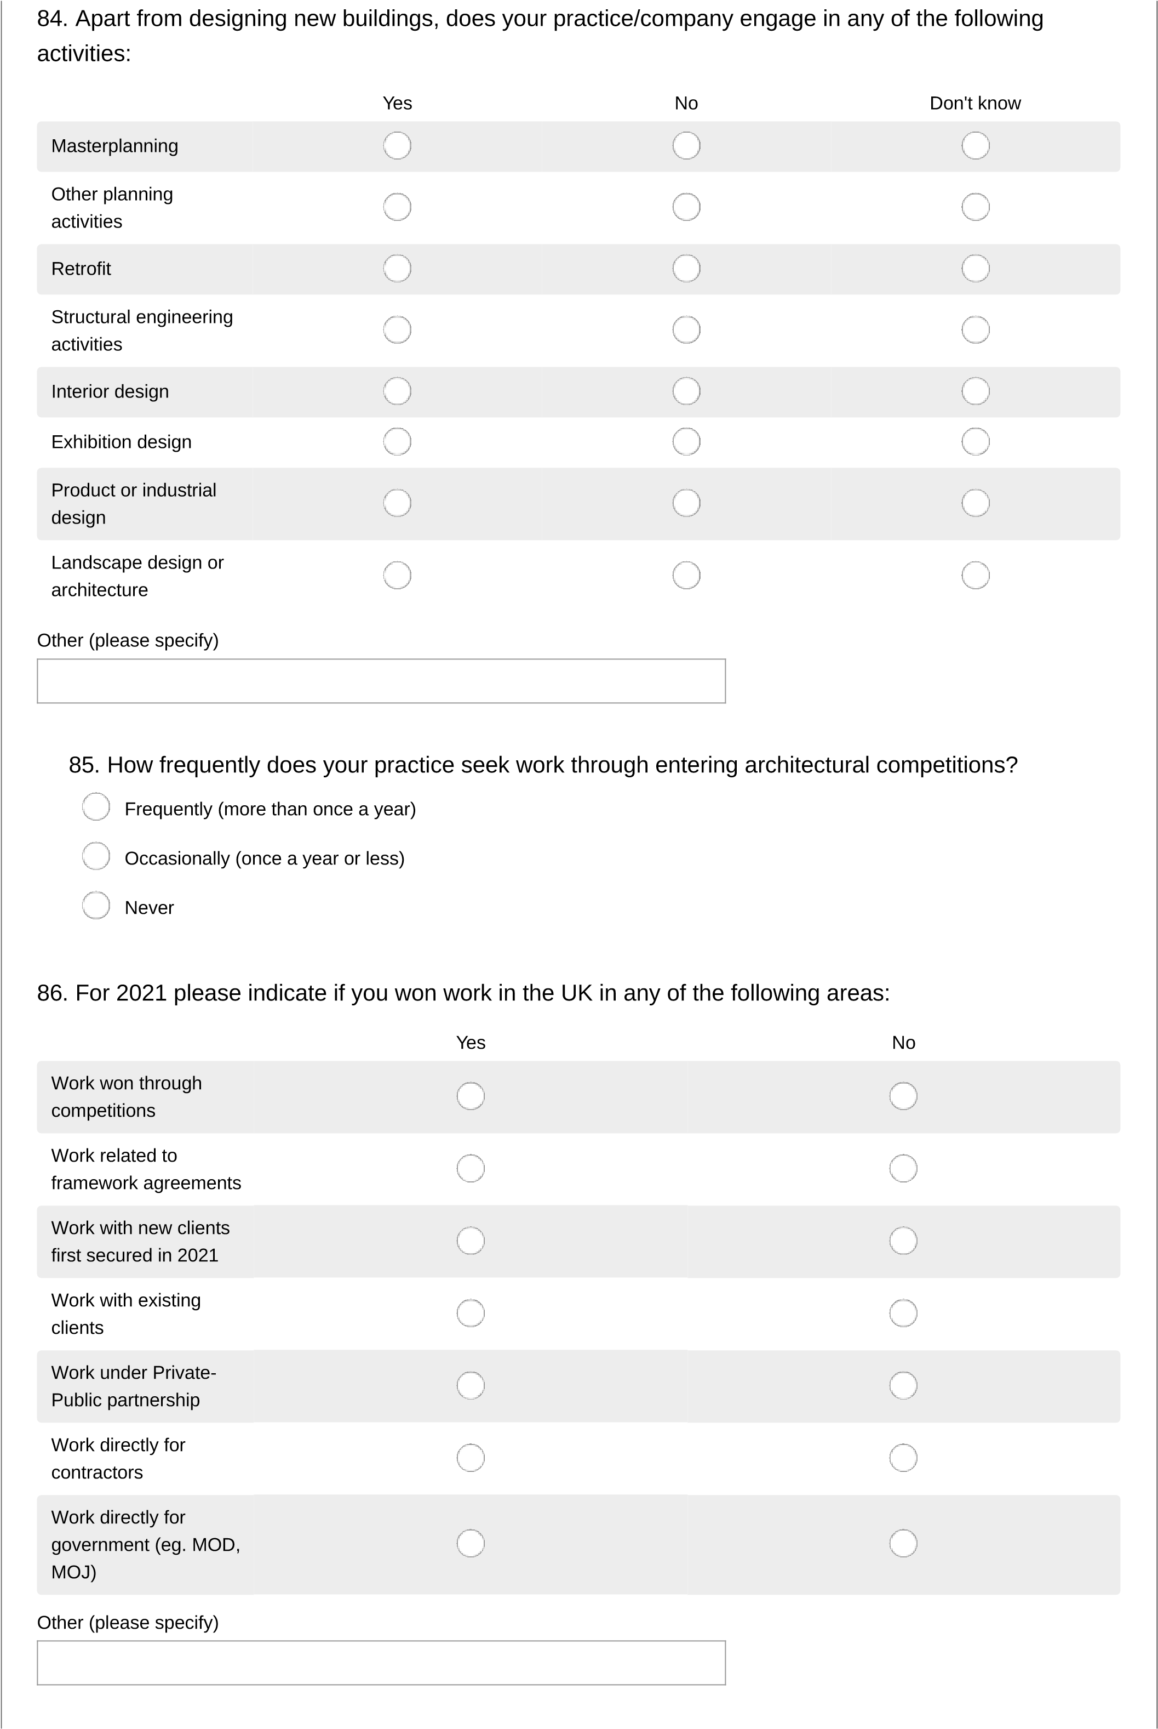

AJ100 Survey 2022
Section 10: Design technologies in use, social media and collaborations

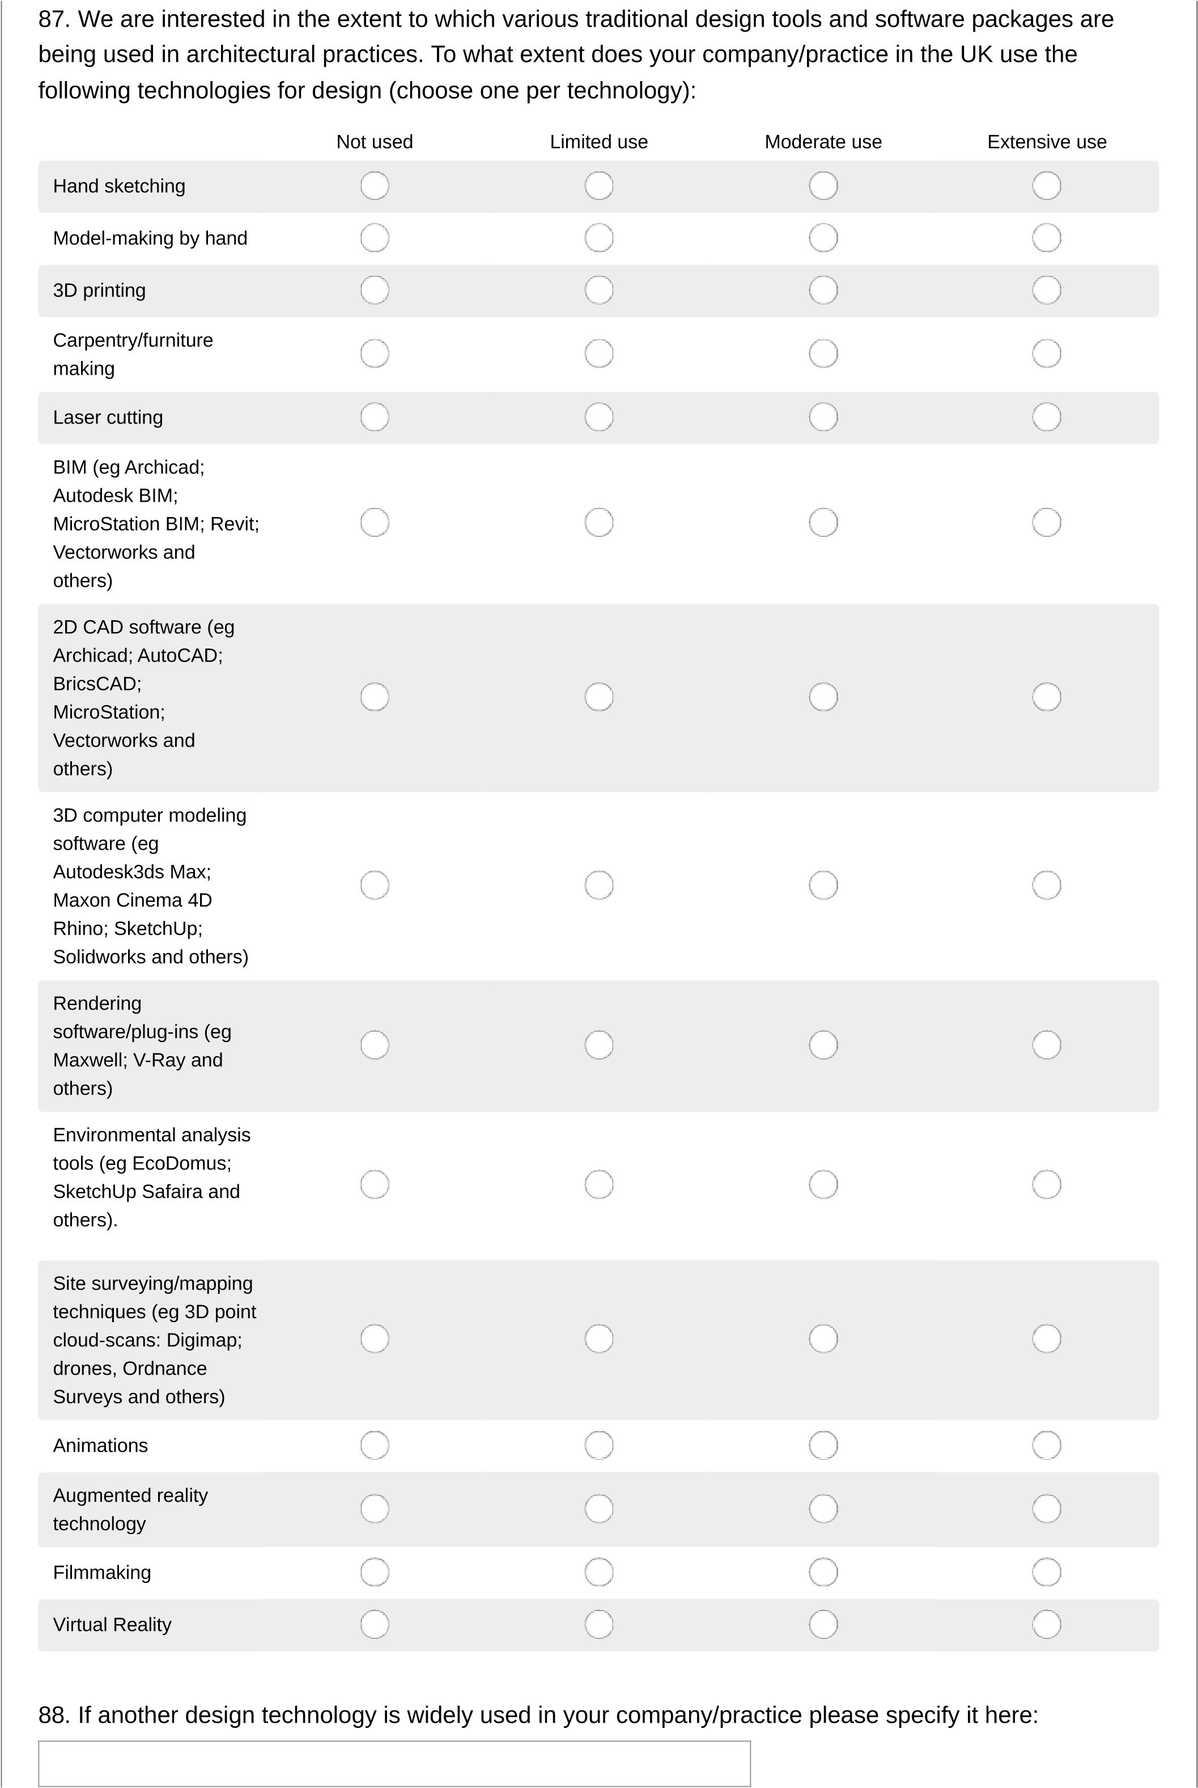
89
.

How much in £ (GBP) did you invest in software and IT in the last financial year in the UK? Please
answer without £ symbol, e.g. 10000.

Section 11.1: Buildings: projects completed in the UK
90
.

Please identify your three most significant projects completed in the UK in 2021. These may be
noteworthy in terms of income, learning, prestige, etc.
Please include the following in the text box below:
1
.
Name of building/project
2
.
Location (UK town/city)
3
.
Client
4
.
Significance (for example, approach to sustainability, community impact, place-making).
Please make sure each image is clearly named with the title of the project and the photographer.

No file chosen
91
.

Please upload 3 high res images of the buildings for publication in a JPEG format, max 10 MB each
Image 1

Choose File
Choose File
Please make sure each image is clearly named with the title of the project and the photographer.

No file chosen
92
.

Image 2

Choose File
Choose File
Please make sure each image is clearly named with the title of the project and the photographer.

No file chosen
93
.

Image 3

Choose File
Choose File
Section 11.2: Buildings: projects completed outside the UK
94
.

If applicable, please submit up to two significant projects completed outside the UK in 2021. These may
be noteworthy in terms of income, learning, prestige, etc.
Please include the following in the text box below:
1
.
Name of building/project
2
.
Location (town/city)
3
.
Client
4
.
Significance (for example, approach to sustainability, community impact, place-making).
Please make sure each image is clearly named with the title of the project and the photographer.

No file chosen
95
.

Please upload up to two high-res images of your project(s) (eg. photos of the building for publication in
a JPEG format, max 10MB each).
Project 1

Choose File
Choose File
Please make sure each image is clearly named with the title of the project and the photographer.

No file chosen
96
.

Project 2

Choose File
Choose File

Section 12: Building of the Year Award
The Building of the Year category will be decided by a panel of judges and announced at the AJ100 Awards. Please complete the following to be considered for this award, and please note that you might be contacted for a site visit by the judging panel.
97. Would you like to enter the Building of the Year Award category?
Yes
No

AJ100 Survey 2022
- Please nominate a single project completed in 2021, which best represents your work to be entered into the AJ100 Building of the Year Award:

- Country where your project is located:

- Client:

- Please provide a summary of no more than 300 words demonstrating the design skill, approach to sustainability, procurement process and client satisfaction of the building you have nominated.

- Please upload three separate high-res images (e.g photos of the building for publication in a JPEG format. Max 10MB). NB. Please include any photographer credits and make sure each image is clearly named with the title of the project.
Image 1:
No file chosen

Choose File
Choose File
103. Image 2  Choose File  Choose File | No file chosen
104. Image 3
No file chosen

Choose File
Choose File
Section 13: Client of the Year
105
.

Name the best client you have worked with in the past year:

106
.

Why are they the best client you worked with in 2021?

107
.

Client contact name

108
.

Client contact email*
Please get the consent of your client to submit this information.

109
.

Client contact phone number*
Please get the consent of your client to submit this information.

110
.

Name the client you would most like to work with:

111
.

Why would you like to work with this client?

This is awarded to the most successful collaboration on a project or initiative over the past 12 months. The collaboration could, for example, be with an artist, a designer, a scientist, a member of the local community, or another stakeholder. It may be with another architect or a firm in another sector. Entries could also include an exceptional collaboration in 2021 between a design architect and an executive architect.
Section 14: Collaboration of the Year Award
Each practice will need to explain how the partnership came about and what made it an outstanding success. Entrants are advised that judges will be looking for evidence of specific outcomes of the successful collaboration, and information on how the collaboration went beyond that expected from an ordinary positive working relationship. What changed because of this collaboration, and how?
This category will be decided by a presentation to a panel of judges and announced at the AJ100 awards.
112. Would you like to enter the Architectural Collaboration of the Year Award category?
Yes
No

113
.

What collaboration from the past year are you entering?
Permission from third parties must be given where third-party contact details are requested.

114
.

Please provide a summary of no more than 300 words on why this collaboration should win:

115
.

How did the collaboration come about?

Contact name
Contact phone number
Contact email
116
.

Collaborator contact details

No file chosen
117
.

Upload two high-res image of the collaboration in a JPEG file format (up to 10MB each). Please
include any photographer credits and make sure each image is clearly named with the title of the project.
Image 1

Choose File
Choose File

No file chosen
118
.

Image 2

Choose File
Choose File
To be considered for the Sustainability Initiative of the Year Award, firms will need to submit an initiative that demonstrates the practice's exemplary/innovative approach to sustainability. This must have been delivered in the calendar year of 2021.
Section 15: Sustainability Initiative of the Year Award
For example, the initiative could be a specific project that demonstrates an exemplary aspect of sustainability, or a piece of research or pro bono work that showcases sustainability or furthers sustainable practice. It could also be a significant change in the way the practice is run that promotes sustainability (such as embedding sustainability in project delivery or staff training).
This award category will be decided by a presentation to a panel of judges and announced at the AJ100 awards.
119. Do you want to enter the Sustainability Initiative of the Year Award?
Yes
No
Name
Completion date
mm/yyyy
)
(
Location
120
.

Your sustainability initiative

121
.

Please complete a 300-word (maximum) summary explaining the project's sustainability
achievements.

No file chosen
122
.

Upload three high-res images of the project in a JPEG file format (up to 10MB each). Please include
any photographer credits and make sure each image is clearly named with the title of the project.
Image 1

Choose File
Choose File

No file chosen
123
.

Image 2

Choose File
Choose File

No file chosen
124
.

Image 3

Choose File
Choose File
Additional comments
125
.

Does your practice have a director of sustainability or equivalent? Please indicate their level of
seniority in the comment box.

Yes - full time
Yes - part-time
Other - please specify role
No - if so, please explain below

AJ100 Survey 2022
126. If yes, how are they funded?
General business revenue
Fee-earning sustainability services
Other (please specify)
127. Do you have a sustainability team?
Yes
No

128.  129. How often does your  Design review  Advocacy (with clients within practice, with consultants)  BREEAM assessments  Energy modeling  Daylight modeling  Informal guidance  Training  Strategy | Extensively | AJ100 Survey 2022  How large is your sustainability team, how frequently does it meet, and what is the team's remit?  sustainability team carry out the following tasks:  Occasionally | Infrequently | Not at all
130. Do you have a specific approach to delivering sustainability that is used on all (or most) of your built projects?
Yes No
131
.

If yes, please provide a brief description

132. Do you advocate retrofit to your clients over demolition?
Yes, frequently
Yes, occasionally
No
None of the above
133
.

Please give an example of where your advocacy has resulted in a retrofit rather than a demolition and
new build.

- What percentage of your built projects are designed to perform beyond Part L minimum improvement obligations?
0-19%
20-39%
40-59%
60-79%
80-100%
N/A
- Does your practice measure its own carbon footprint?
Yes
No
136
.

What is your carbon footprint?

137. Does your practice measure the operational emissions of its projects?
Always
Frequently
Occasionally
Never
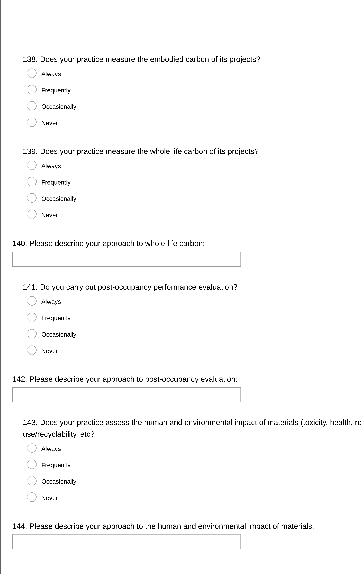

145
.

Is your practice ISO 14001 certified?

Yes
No
If yes, how many?
146
.

Does your practice employ LEED accredited professionals in house:

Yes
No
If yes, how many?
147
.

Does your practice employ BREEAM accredited professionals in house:

Yes
No
If yes, how many?
148
.

Does your practice employ Passivhaus-trained designers in house:

Yes
No
If yes, please describe
149
.

Has your practice undertaken any sustainability research and development in 2021?

Yes
No
None of the above
If yes, please give details (such as Passivhaus, Green Register, CPD or other).
150
.

Has your practice undertaken any sustainability training?

Yes
No
151. Are you a member/signatory of the following?
Architects Climate Action Network (ACAN)
Architects Declare
RIBA 2030 Climate Challenge
UK Green Building Council
London Energy Transformation Initiative (LETI)
None of the above
152
.
Since becoming involved with this organisation/these organisations, what sustainability measures
have you put in place?

Section 17: Sustainability Champion of the Year
The Sustainability Champion of the Year Award will be given for an outstanding contribution to the sustainable design agenda in the calendar year of 2021.
Nominations can be made for either an individual or a joint entry. Nominees could either be working within an architectural practice or within the wider built environment.
153. Would you like to nominate a Sustainability Champion?
Yes
No
154
.
Who would you like to nominate for the Sustainability Champion of the Year award?

155
.

Please provide a summary of no more than 300 words describing your nominee(s) contribution:

No file chosen
156
.

Upload a high-res JPEG headshot (up to 10MB) of the nominee
Please include photo credits

Choose File
Choose File

Section 18: Innovation of the Year
The practice that wins this award will have made an innovation that has transformed an aspect of its work. This may be a technological innovation - whether high-tech or low-tech - or any other example of inspirational problem-solving. This award category will be decided by a presentation to a panel of judges and announced at the AJ100 awards. Judges will be looking for evidence of the impact of this innovation.
157. Would you like to enter the Innovation of the Year Award?
Yes
No
158
.
Please outline in a maximum of 300 words how your practice has made an innovation that has
transformed an aspect of your work in 2021:

No file chosen
159
.

Upload up to three high-res JPEG (up to 10MB) images to support your entry and include any image
credits.
Image 1

Choose File
Choose File

No file chosen
160
.

Image 2

Choose File
Choose File

No file chosen
161
.

Image 3

Choose File
Choose File

Section 19: Community Impact of the Year Award
This is awarded to a project that demonstrates both a deep engagement with the local community and an exceptional outcome for all stakeholders. The project must have been delivered in 2021. Judges will be looking for examples of how community engagement shaped the project and for evidence of constructive consultation and significant benefits for the community post-completion.
Please note: if you are shortlisted for this award, you might be contacted to arrange a visit for the judging panel, who would be particularly keen to hear from community stakeholders about the impact of the project.
162. Would you like to enter the Community Impact of the Year award category?
Yes
No
163
.
What project from 2021 are you entering?

164
.

Please outline in a maximum of 300 words why this project should win?

No file chosen
165
.

Upload three high-res JPEG images (up to 10MB) to support your entry and include any image
credits.
Image 1

Choose File
Choose File

No file chosen
166
.

Image 2

Choose File
Choose File

No file chosen
167
.

Image 3

Choose File
Choose File

Section 20: Your awards
168. Did you win any UK architectural or design awards in 2021?
Yes
No
169
.
How many UK architectural or design awards did you win in 2021?

170
.

Please state the name(s) of the award(s) you won and awarding organisation:

Section 21: Opinions
171
.

Which do you consider to be the best architecture school in the UK?

172
.

Which (living or dead) architect most inspires the work of your practice?

173
.

Who would you identify as the next emerging architectural star?

174
.

Who is the most influential non-architect working in the built environment?

175
.

Please name the architectural practice or company that you most admire. (This can be for quality of
their work, their ethos, or business performance):

Practice 1
Practice 2
Practice 3
Practice 4
Practice 5
176
.

Please name up to five architectural practices or companies which you consider your practice or
company is comparable with i.e., these are your peers or reference group. If you compare your business
with many others, please name the five that you consider most similar to yourselves:

177
.

What are the biggest issues facing architects today? (max 300 words)

178. Practice success: Considering all the factors that contribute to the making of a good architectural practice, and from your practice's perspective, please allocate 100 points across the following seven criteria:
Ability to win new
business
Being a good place to
work (high staff morale)
Clients satisfaction and
repeat business
Deliver environmentally
sustainable projects
Design quality
Financial success - profit
margin
Recognition within the
architecture profession
Section 22: AJ100 events
179
.

The Architects' Journal invites keynote speakers to address the regular AJ100 events. Please name
any speakers you would like to hear speak at an AJ100 event:

Section 23: Contribution to the Profession Award
180
.

Please nominate an individual and the company they work for who you feel has contributed
something of outstanding importance to the industry - previous winners include Peter Barber, Yvonne
Farrell and Shelley McNamara, Norman Foster, Zaha Hadid, David Chipperfield, Alison Brooks, Richard
Rogers, David Adjaye, and Sadie Morgan.

Section 24: Senior partner or director approval
181
.

Please provide the contact name of a senior partner or director who has approved the information
submitted to AJ100 and authorised its publication

If it is not you, please supply the full name and email address for the person we should liaise with
182
.

If your practice does make this year's AJ100, your practice will have the chance for a senior member
of the company to attend one of the six AJ100 Club Events that happen across the year; are you the best
person to coordinate who would attend?

Yes
No

Do not click 'Done' if you are not ready to submit your survey.
183. The survey results will be revealed at the AJ100 Awards 2022. Contact the AJ team for further enquiries or if you wish to request a copy of your completed AJ100 2022 Survey:
AJ100.AWARDS@emap.com
Tick if you wish to receive e-mails from AJ events
Tick if you wish to receive emails from EMAP about similar events
Tick if you wish to receive third party emails

