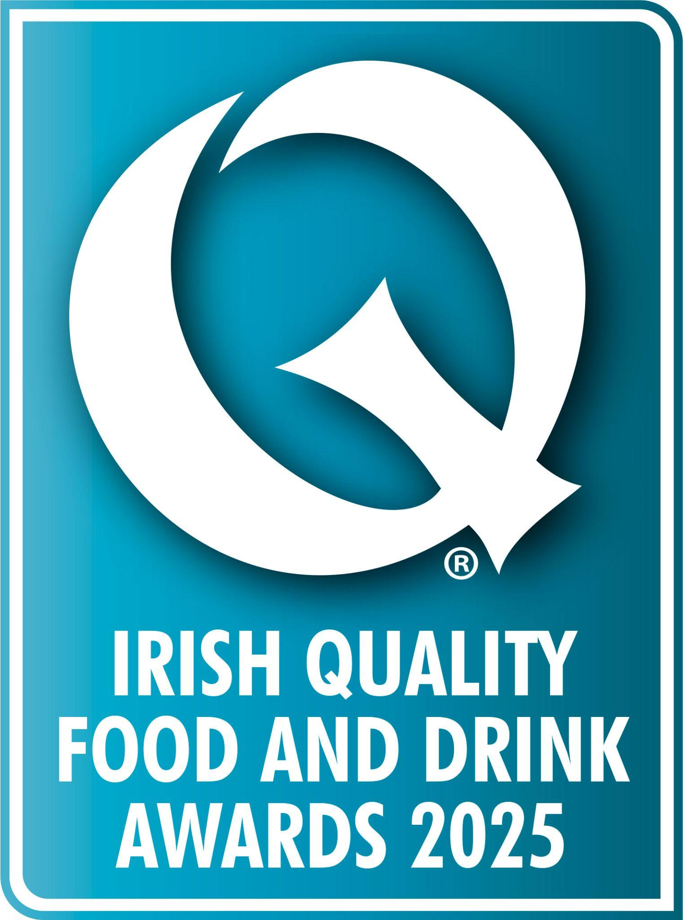

**[Company Name] triumphant in the Irish Quality Food and Drink Awards 2025!**

**[Product Name], produced by [Company Name] won a [Bronze/Silver/Gold] award in the most prestigious awards in the food and drink sector in Ireland.**

[Company Name], based in [location] were awarded a prestigious Irish Quality Food and Drink award in the [Category Name] category this month.

The esteemed panel of judges, comprising of recipe developers, chefs, buyers, and other industry professionals, put each entry through a rigorous judging process so to even be shortlisted for an Irish Q is a huge achievement.

**The Judging Process**

This year, judging took place over three weeks at Leopardstown Racecourse in Dublin. One by one, each product is brought into the judging room and reviewed by the panel. First, judges review the product individually, inputting their personal feedback based on their initial impressions using the key judging criteria.

Following individual reflection, judges will discuss the entry as a collective and debate the merits of each product with reference to the below key criteria:

* Taste
* Texture
* Flavour
* Aroma
* Ingredients list
* Provenance
* Product appearance
* Packaging
* Price point/value for money
* Innovation/aims in the marketplace

To be awarded an Irish Quality Food and Drink Award, a product must excel in every one of these areas.

**What it means to win an Irish Quality Food and Drink Award**

[Optional quote from your business]

For more information about [Company Name], visit their website: [website address]

**About the Irish Quality Food and Drink Awards**

Now in its 12th year, the Irish Quality Food and Drink Awards have become a mark of excellence for food and drink products in the grocery retail, wholesale and foodservice sectors.

To view the 2025 winners of the Irish Qs, visit the website at [irish.qualityfoodawards.com](https://irish.qualityfoodawards.com/IQFDA24/en/page/2024-meet-the-winners).

Congratulations [Company Name] for being awarded [Bronze / Silver / Gold] for their [Product Name].