PHOENIX-IT
We are a Romanian private company, with more than 14 years of experience in IT&C. We started the activity in 2004 by delivering IT services in projects based on Microsoft technologies. Our first competencies where oriented towards business solution implementation such as: Dynamics NAV, Dynamics CRM, SharePoint Server and development of specialized ERP modules.

Starting in 2012, the company has expanded its expertise through technology partnerships with international leaders in their areas, such as Intel, Fortinet, Oracle, Symantec, Bitdefender, Veritas, Veeam, Cisco, Adobe, etc.
All of these skills have enabled Phoenix to address increasingly complex projects and to simultaneously promote the company in the field of complex system integrators.

Business Profile
Our goal is to be a trusted partner by delivery performant software and infrastructure solutions and high-quality IT services. We tailor our solutions to fit the customer’s specific needs, business focus and preferences, by putting together all our business experience, project management skills and technical competences (consultants, developers, system engineers).
PHOENIX-IT has three strategic directions for development:
I. Solution Provider – analyze, design, customization, development and implementation services for: Content and Collaboration Solutions, Unified Communications, Virtualization Solutions, IT Infrastructure Management, Business Applications, Volume Licensing solutions, Software Asset Management (SAM) and Cloud Solutions.
II. Custom Software Development - Learning Management Solution, Case Management System (Asigno), Patient Management System, Document management, Citizen portal, Ticketing application, e-Commerce, Business Intelligence, etc.
III. Datacenter - In 2014, PHOENIX IT initiated a project that aims to achieve a fully equipped DATA CENTER, which has been operational since 2015. The Datacenter respects the international datacenter’s standard as TIA Tier 3, being able to offer to customer high quality services as Infrastructure-as-a-Service (IaaS), Security-as-a-Service (SecaaS), Software-as-a-Service (SaaS).

Customer References
Romanian Government - Phoenix IT has implemented an e-learning platform at The General Secretariat of the Government (SGG) - “Virtual center staff training”, a platform which provides access to 500 internal users and an unlimited number of external users. The platform is designed for training and assessment of civil servants from SGG, subordinated public institutions and civil servants operating in decentralized institutions. Phoenix IT has implemented a modern datacenter equipped with routers/ firewalls, network devices, 10 servers, a complex storage solution, a tape library and also uninterruptible power and protection equipment, to increase the availability of the solution.
In terms of infrastructure software, the solution offers LDAP services, firewall and proxy, portal platform, database, e-mail, configurations and infrastructure management, antivirus and backup based on the latest Microsoft and Symantec technologies. The project has completed in January 2014. Phoenix IT has provided also between 2014-2015 and 2017-2018 maintenance for the e-learning system.

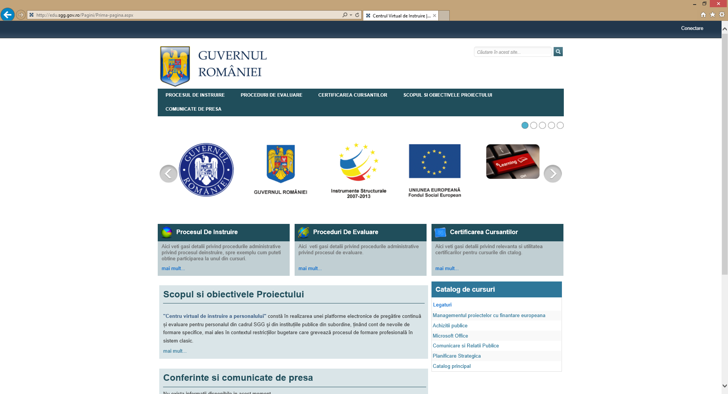

National Registry of Legal Medicine - Phoenix IT has implemented in 2015 the integrated software solution called National Registry of Legal Medicine that is used by all 42 legal medicine entities in Romania (IML Iasi, INML “Mina Minovici” Bucuresti, IML Cluj-Napoca, IML Craiova, IML Timisoara, IML Targu-Mures and other 36 county legal medicine services). The project has consisted in designing and implementation of a datacenter, securing the network and communications, a dynamic case management system which represents the core of the solution, a knowledge management portal for employees, an application for citizens, a decision support system based on business intelligence technology, videoconferencing and email services. The interoperability with institutional partners (Ministry of Internal Affairs, Ministry of Justice, National Health Insurance House) is ensured through SOAP web services.

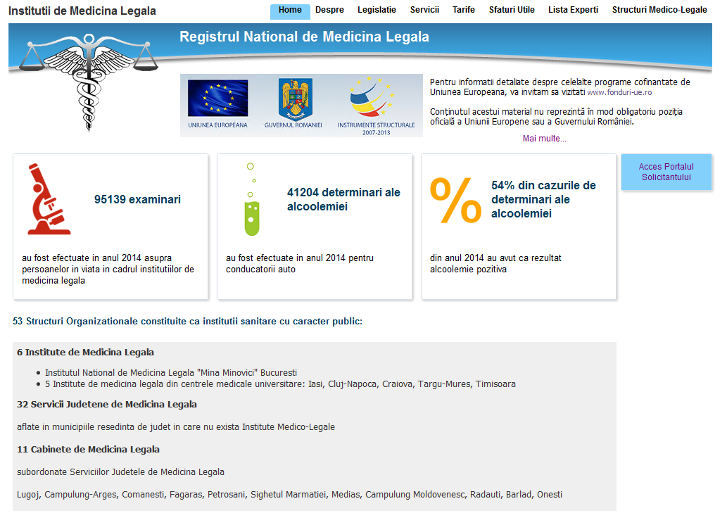

County Emergency Hospital of Bacau - Phoenix IT has delivered in 2018 the project D.A.L.I. consisting in extension to the existing Hospital Information System. We provided business analysis services, design services, engineering services, cost-benefits analysis, extensions and upgrades of the application software modules and project management.

County Prahova - Phoenix IT has implemented in 2015 an integrated system which consisted in datacenter design and implementation of a centralized management solution for the Agricultural Registry, including GIS.

County Bihor - Phoenix IT has provided between 2017-2018 and 2018-2019 maintenance for the county integrated system: hardware, software and centralized management solution for the Agricultural Registry, including GIS.

Isys Professional - Phoenix IT performed for Isys Professional a project of implementation of eCommerce platform, aiming at increasing company competitiveness. The platform consists of a virtual store which presents the products and services provided by Isys Professional, including online ordering. Phoenix IT has ensured the hardware, application software and integration services with existing applications, training and post-implementation services.

Other customers:

Utilities:  - Apa Nova Ploiești (Veolia)  - Conpet SA  - Electrica Serv SA  - Electrica Furnizare SA  - Teletrans | Banking-Insurrance:  - CEC Bank  - Credius IFN SA  - Asito Kapital Asigurari-Reasigurari  - Eurolife ERB Asigurari  - Euroins Asigurare-Reasigurare
Distribution:  - Interbrands Marketing & Distribution  - Augsburg International  - Trima Birotică & Papetărie | Production:  - Electrotel  - Acrelec  - Pureworld Engineering  - SEA Romania  - ViaCon
Academic:  - Academia Națională de Informații „Mihai Viteazul”  - Universitatea Națională de Apărare Carol I  - Universitatea de Medicină și Farmacie “Carol Davila” București  - Universitatea Politehnica București  - Universitatea din București - Facultatea de Biologie  - Universitatea de Medicină și Farmacie “Gr. T. Popa” Iași | Public Institutions:  - Ministerul Economiei  - Registrul Auto Român (RAR)  - Societatea de Transport București (STB)  - ISCTR - Inspectoratul de Stat pentru Controlul în Transportul Rutier  - Consiliul Județean Călărași  - Agenţia pentru Dezvoltare Regională Sud Muntenia  - Primăria Ploiești  - Compania de Utilități Publice Dunărea Brăila  - DGASPC Sector 3

IT Certifications and Partnerships with IT Vendors

- Microsoft Gold Certified Partner;
- Oracle Gold Partner;
- Bitdefender Gold Partner;
- Veritas Silver Partner;
- Veeam Silver Service Provider, Registered Reseller;
- Fortinet Silver Partner;
- Symantec Registered Partner;
- Kaspersky Lab Authorized Reseller;
- Intel Technology Provider Registered Partner;
- Fujitsu Select Registered Partner;
- HP and Aruba Partner;
- Cisco Registered Partner;
- Adobe Registered Reseller;
- APC Registered Partner;
- Teltonika Authorized Reseller.

ISO Certifications

- Quality Management System ISO 9001:2008;
- Information Security Management System ISO 27001:2006;
- Environmental Management System ISO 14001:2005;
- Services Management System ISO 20000-1:2011.

