NICE Atrial Fibrillation (AF) guidelines 2021 – So, what’s new?

Professor Ahmet Fuat
GPSI Cardiology, Darlington and Professor of Primary Care Cardiology, Durham University
Education and Research Lead, PCCS

Helen Williams
Consultant Pharmacist for Cardiovascular Disease, South East London CCG
Secretary, PCCS

The revised NICE AF guidelines were published on April 27th, 2021 and recommend some changes to practice which will affect primary care.

Diagnosis: Perform manual pulse palpation if AF suspected. Perform 12-lead ECG in people with an irregular pulse, with or without symptoms, to diagnose AF. If paroxysmal AF is suspected use 24-hour ambulatory ECG monitor if episodes <24 hours or 24-hour ambulatory ECG, event recorder or other ECG technology for an appropriate period if episodes >24 hours apart.

People presenting acutely with AF: If new onset AF with life-threatening haemodynamic instability then refer for emergency electrical cardioversion without delaying to achieve anticoagulation. For new onset AF without life-threatening haemodynamic instability lasting <48 hours, assess CHA2DS2VASc score and offer anticoagulation where indicated plus either rate or rhythm control. If onset >48 hours, offer anticoagulation where indicated and rate control.

Stroke risk assessment: While stroke risk assessment remains the same, using CHA₂DS₂VASc, NICE recommends this is undertaken for all patients with any form of AF (symptomatic or asymptomatic paroxysmal, persistent, or permanent), as well as in those with atrial flutter. The guidance recommends that stroke risk assessment should also be undertaken if there is continuing risk of arrhythmia recurrence after cardioversion back to sinus rhythm or catheter ablation.

Bleeding risk assessment: Bleeding risk assessment should be undertaken when considering starting anticoagulation in people with atrial fibrillation and when reviewing people already taking anticoagulation. However, NICE recommends a move away from the HASBLED risk score and endorse the ORBIT bleeding risk score as it was felt to have a higher accuracy than other tools in predicting bleeding risk. ORBIT-AF assesses risk using: sex, haemoglobin < 13mg/dl or haematocrit<40%, age over 74 years, history of bleeding, CKD stage three or greater and concomitant use of antiplatelet therapies. NICE indicates that clinicians should wait until ORBIT-AF has been incorporated into IT systems, before switching from their existing bleeding risk assessment tool.

ORBIT-AF Bleeding risk score categories and observed major bleeding rates
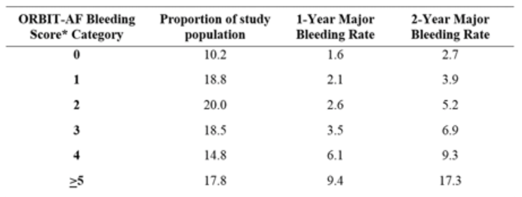
Circulation. 2014;130:A18832

NICE also points to the need to address modifiable risk factors for bleeding, including uncontrolled hypertension, poor control of international normalised ratio (INR) in patients on vitamin K antagonists, concurrent medication, including antiplatelets, selective serotonin reuptake inhibitors (SSRIs) and non-steroidal anti-inflammatory drugs (NSAIDs), harmful alcohol consumption and reversible causes of anaemia.

Anticoagulation: As previously, anticoagulation should be offered to people with a CHA₂DS₂VASc score of ≥2 and be considered for men with a score = 1. However, NICE now recommends a direct oral anticoagulant (DOAC) as the first line anticoagulant for stroke prevention in AF, in preference to warfarin or other vitamin K antagonists (VKA). No specific DOAC is preferred and all should be used in line with their respective NICE technology appraisal.

Where DOACs are contraindicated, not tolerated or not suitable in people with atrial fibrillation (mechanical heart valves or moderate to severe mitral stenosis), a VKA should be offered as an alternative. For those stable on a VKA, the option of switching from a VKA to a DOAC should be discussed at the next routine appointment.

Do not dos: NICE clearly recommends that anticoagulation should not be offered to people at very low risk of stroke, equating to a CHA₂DS₂VASc score of 0 for men or 1 for women. Also, that anticoagulation should not be withheld solely because of a person's age or their risk of falls.

Stopping anticoagulation: anticoagulation should not be stopped in people with a diagnosis of atrial fibrillation, solely because atrial fibrillation is no longer detectable. Decisions to stop anticoagulation should be based on a reassessment of stroke and bleeding risk using CHA2DS2‑VASc and ORBIT and a discussion of the person's preferences.

Rate or rhythm control: Offer rate control as first line treatment strategy, unless:
- AF has a reversible cause
- the person has heart failure thought to be caused by atrial fibrillation
- the person has new onset AF (<48 hours)
- the person has atrial flutter and their condition is suitable for ablation
- a rhythm control strategy is more suitable based on clinical judgement (e.g. very symptomatic despite rate control).

Echocardiography: Only perform transthoracic echocardiogram (TTE) if a baseline echocardiogram is important for long-term management, cardioversion is being considered, underlying heart disease (valve disease or heart failure) is suspected or if refinement of clinical risk stratification for anti-thrombotic therapy is needed.

Rate control strategies:
- Offer a standard beta-blocker (BB) (not Sotalol) or a rate-limiting calcium channel blocker (CCB) as initial monotherapy unless the person is sedentary
- Base drug choice on symptoms, heart rate, comorbidities and preferences
- Consider digoxin therapy for non-paroxysmal AF only for people who are sedentary or cannot use other rate-limiting agents
- Do not offer amiodarone for long-term rate control
- For people with AF and chronic heart failure follow NICE guidelines for heart failure on BB and avoid CCBs
- If monotherapy does not control symptoms and symptoms are thought to be due to poor rate control, consider any two of the following – a beta-blocker, diltiazem and digoxin.

The NICE guidance for AF can be found here: https://www.nice.org.uk/guidance/NG196

For more information about the PCCS please visit: https://pccsuk.org/2020/en/page/about-us

For more information about Heart Rhythm Alliance visit: www.heartrhythmalliance.org

