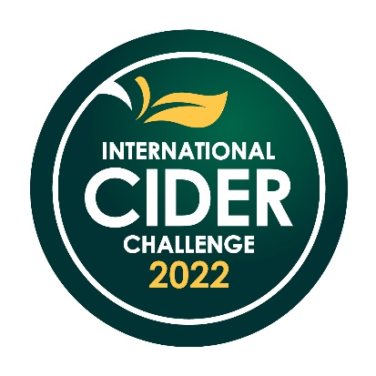

EMBARGOED UNTIL JULY 14 2022
INTERNATIONAL CIDER CHALLENGE 2022 PRESS RELEASE
International Cider Challenge praises ‘exceptional quality’ as results come in
The results of the International Cider Challenge (ICC) are in, with Vindpust Hardangergutane Ice Cider leading the way as Supreme Champion in the tasting competition.

With a spread of entries from five continents and 60 cidermakers of varying sizes, this year’s ICC saw 16 golds, 53 silvers and 53 bronze medals. Judges included cidermakers, drinks writers, wholesalers, on and off-trade owners and buyers.

Headed up by ICC chairman James Finch, the taste table captains also awarded trophies to Sandford Reserve, Cidentro Traditional Method, Cidrerie Beaupré, Purple Twist 2021, Barrel #4 and NeRø Issider, after sampling around 150 ciders.

Finch described the supreme champion, which was in the Acid Led category, as a “masterclass in balance and flavour”, noting “exceptional quality” across the board.

This year’s ICC saw a change in categories in an effort to move away from geographical focus, with West Country becoming Tannin Led and New World becoming Acid Led. Tannin Led, Acid Led and Flavoured were the biggest categories, with a reduction in Low & No, Perry and Pear Cider. Golds were awarded across Acid Led, Rosé, Naturally Sparkling, Speciality, Wood Aged, Ice and Tannin Led, which made a comeback after winning no golds in 2021.

In the Design & Packaging category, Kicking Goat from Red Cow Cider came out on top as judges awarded the brand a trophy and a gold medal. Gravity Theory from Drinkscraft and Tālavas Semi-Dry Apple from Tālavas Sidrs followed suit, both winning a gold medal, while three silvers and one bronze were also awarded.

“Among the themes that stood out was an increase in bold flavours – for example, we saw Blood Orange, Grapefruit and Plum & Ginger among others,” said Finch. “We also saw a wider embrace of barrel influence as well as Naturally Sparkling, both bottle-conditioned and fermented.
“It was an absolute honour to be asked back as chairman for 2022, and it proved to be another exceptional year for judging international ciders.
“I’m not sure there is another cider competition in the world with such a global reach of entries.”

Notes to editors:
For the full list of medal winners, see Drinks Retailing’s Buyers’ Guide to Cider or visit: internationalciderchallenge.com International Cider Challenge 2022 - 2022 Results
About the International Cider Challenge:

Now in its 12th year, the International Cider Challenge is the most authoritative, respected, and influential cider competition in the world.
Judges include some of the shrewdest cider judges in the land – retailers, importers, producers, and writers.
Judges study each cider in turn, considering the appearance, the aroma, the taste, and the finish, before discussing their findings with other judges and reaching a consensus on which medal to award. The level of knowledge and experience of the judges is striking and, for a cider to achieve any kind of medal from such exacting critics is a real achievement.

