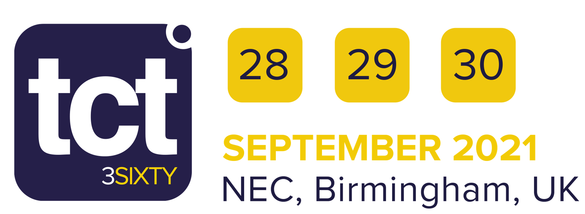
Deadline: Friday 27 August 2021

COVID-19 Risk Assessment – Build, Open and Breakdown

In the context of the current global COVID-19 pandemic, every exhibitor (shell scheme or space only) has a legal responsibility to carry out a thorough risk assessment of their stand activities with the aim of limiting potential and unnecessary exposure to COVID-19 through close proximity airborne transmission and direct touch. We understand that this may be daunting, and the COVID-19 landscape is uncharted territory to us all. To help, we have created a list of items to be considered. This should be used as a planning tool to help you complete your risk assessment. These are by no means comprehensive and are there to serve as guidelines. You must tailor your own comprehensive set of controls relating to your own individual stand set-up. Remember your stand is your ‘home’ and as an exhibitor you have responsibility for your immediate environment and safety within it.

Please read the COVID-19 Risk Assessment Guidance document that offers advice on how to complete this form.

Exhibiting Company: | Stand Number:
Stand Type (please circle/delete as necessary): Space Only Shell Scheme Hybrid Shell Scheme Pod

Name of person responsible for this COVID-19 risk assessment: | Work no.:
Email: | Mobile no.:

Contact Points | Who is at Risk* | Transmission Routes | Controls | Advisory Controls / Notes

I declare that to the best of my knowledge that all COVID-19 safety measures and controls have been thought through and will be actioned regarding this stand.

Signed: | Name: | Date:

