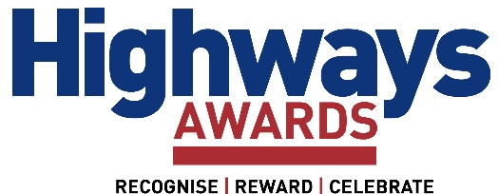

COVID-19 SAFETY FAQS
Are there any requirements of entry to the event?
All attendees will be required to show proof of COVID-19 status on arrival at the venue, this will need to be in the form of:
- Proof of negative Lateral Flow Test taken within 24hrs of arrival - Lateral Flow Tests are available for free from GOV.UK or from your local pharmacy.
- Proof of completion of a full course of vaccination 14 days (2 weeks) prior to arrival.

If you are unable to provide the above then we will need:
- Proof of natural immunity based upon a positive PCR test within 180 days of the event (including 10 day’s self-isolation following the result)

Why do I need to prove my COVID-19 Status?
Current information and guidance suggest that verifying attendees’ COVID-19 Status is an effective way of reducing the risk of transmission among large groups. Studies of those who have received a full vaccination course demonstrate that the risk of carrying and transmitting the disease is vastly reduced. For those not vaccinated, a lateral flow test has been proven as a reliable way of indicating if people are currently carrying the virus. Therefore, this evidence suggests that this is the best way to keep everyone safe.
How do I show proof of my COVID-19 Status?
If you are a resident in England, you can do this via the NHS COVID Pass which lets you share your coronavirus (COVID-19) vaccination records or test COVID-19 status in a secure way.
Or proof of your negative Lateral Flow Test. To get proof of this, you need to report your results to the NHS. You can do this using one of the below options – you will need the QR Code, or the ID number from the test strip to report your result.
- Report online: www.gov.uk/report-covid19-result
  - Or report by telephone - Lines are open every day, 7am to 11am England, Wales and Northern Ireland: 119 (Free from mobiles and landlines) Scotland: 0300 303 2713 (charged at your standard network rate)
You can show proof of a negative Lateral Flow Test via the NHS COVID-19 Pass, an email or text message.

How do I access the NHS COVID Pass?
You can access your NHS COVID Pass through the free NHS App on a mobile device such as a smartphone or tablet. Proof of your COVID-19 status will be shown within the NHS App.  Please note the NHS App (which contains the NHS COVID Pass) is different from the NHS Covid App used for Track and Trace, see below: | 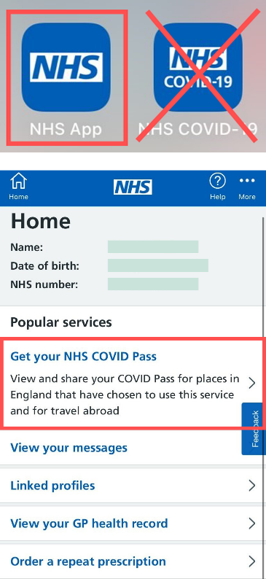
NHS App
NHS Website
You can view your COVID-19 status online and download or print it as a PDF document. To access the service, you’ll need to register for an NHS login if you do not have one already. NHS login registrations may take longer than usual when there are high numbers of requests.
If you do not have access to a smart phone, computer or tablet, you can request an NHS COVID Pass letter via the NHS website or by calling 119 (select the 'NHS COVID Pass service').
Find out more about the NHS COVID Pass here.
How do I get my COVID Pass to gain entry to the event if I'm a visitor from Scotland, Wales or Northern Ireland?
If you live in Scotland, you can find out how to obtain your vaccination status here.
If you live in Wales, you can find out how to obtain your vaccination status here.
If you live in Northern Ireland, you must supply paper proof of vaccination from your GP, or alternatively show a negative lateral flow test result.
Do I need to wear a face covering?
Following proof of your COVID-19 status on entry to the Highways Awards, face coverings are optional and no longer required by law, but the government expects and recommends that people should continue to wear them in crowded and enclosed settings. If it makes you feel more comfortable to wear a face covering, then we would recommend doing so.

Will there be hand sanitiser available?
Hand sanitising stations will be available onsite
What other measures will there be at the event?
- Staggered start times
- A room layout plan which allows for improved circulation
- Clear signage at the event to support relevant safety measures
- Enhanced venue cleaning prior to the event starting and throughout
- Regular sanitisation throughout the event focusing on high-touch point areas e.g. toilets and door handles.
- Hand sanitising stations provided throughout the event
- Hygiene reminders to regularly wash hands and refrain from personal greetings (a handshake or a hug) will be in place throughout the venue.
- Safer payments – contactless payments will be encouraged throughout via card or phone, with an email receipt wherever possible.
- Face coverings are optional and no longer required by law, but the government expects and recommends that people should continue to wear them in crowded and enclosed settings
What should I do it I feel unwell with symptoms of COVID-19?
Please do not attend the event if you are displaying any COVID-19 symptoms. If you should start to feel unwell whilst at the event, please follow government advice by leaving the event and arrange a PCR test immediately.
What happens if there has only been one week between my second vaccination and the event?
In this circumstance proof of a negative NHS lateral flow test taken within 24hrs prior to attending the event would be required, and can be displayed via the NHS App, SMS text, or via email.
What happens if I do not have the NHS app?
Proof of a negative Lateral Flow Test taken within 24hrs prior to attending the event can be used and shown SMS text, or via email - remember to register the result first via the options noted under
'How do I show proof of my COVID-19 Status?'
Proof of vaccine can also be displayed via the NHS website or by downloading and printing off a PDF.
A non-digital letter is also available through the NHS website using the ‘Get your coronavirus (COVID-19) vaccination status letter’ service or by phoning 119.

Who is exempt from the COVID-19 checks?
If you have a medical reason that means you cannot be vaccinated or tested, you will be asked to self-declare this medical exemption.
Are there restrictions for international attendees?
We welcome international attendees to the exhibition on the basis they can prove their COVID-19 Status that are advised by the government at the time of the exhibition.

