NEXUS Enfield Delivering Better Outcomes Nomination

Since its inception in 2018, the NEXUS project was tasked by the Enfield local authority with one outcome - to reduce permanent exclusions from Enfield secondary schools. Given these numbers were historically high year on year, a fresh and imaginative approach was required to break the cycle. This coupled with an increase in youth crime, violence, and exploitation in our borough impelled the council to sanction the establishment and funding of NEXUS. We were tasked with the creation and/or commission of a range of interventions and diversionary activities to reduce permanent exclusions through early identification and support, in schools and across the community.
There is clear evidence that young people respond strongly to diversionary activities and that pupils who are in mainstream education and not confined to the nether regions of Alternative Provision are less likely to become involved in criminal activities and be vulnerable to exploitation. The effects of permanent exclusion on a community is heavy – a Hackney Councillor elaborates on this well when commenting on the murder of an excluded teenager stating it “serves as a sobering example of how permanent exclusion from school can increase a child’s risk of being victim of crime and criminal exploitation – and the potentially devastating consequences of this". (Hackney Gazette, December 2021)
Since 2018, we have grown from a project delivery team of 2 people to have a total of 25 partners and projects, all with different streams of funding, that we deliver in our borough through a joined-up approach. What makes NEXUS unique is that we connect projects and services from external organisations to schools. Typically, organisations have struggled to connect with Enfield schools for several reasons, one being that there has been a historical reluctance to engage with external groups as well as a lack of capacity within schools to develop partnerships with a range of external providers. This has disadvantaged our community massively as it has limited the variety and number of interventions. NEXUS Enfield uses our network of positive, professional relationships we have built within the Secondary Behaviour Support Service, as well as our quality assurance procedures, to connect these organisations and schools through trust. Through this, NEXUS have been able to create partnerships that are creating more opportunities and diversionary activities within our community. Uniquely, NEXUS can tackle a range of issues by delivering multiple targeted, specific projects and programmes in schools and the community to ensure the best possible outcomes are achieved that addresses the existing need.
In the previous academic year, all 22 mainstream Enfield secondary schools received some form of NEXUS intervention.
Innovative projects, joined up approach and imaginative sources of funding
NEXUS has formed several successful partnerships with organisations who are currently delivering interventions to children, young people and their families. These innovative projects have attracted funding from a diverse number of sources, these include MOPAC, Metropolitan Police, National Lottery, Children in Need and the Young Londoners Fund.
The NEXUS offer includes:
- Mentoring programmes addressing a diverse range of topics which include: gang awareness, exploitation, classroom survival, self-esteem.
- Mentoring programme targeting vulnerable girls to boost their self-esteem and equip them with skills to build healthy relationships.
- The creation of HEARD - a parenting forum facilitated by a panel of experts to help parents and carers navigate the challenges of modern parenting. The feedback HEARD receives is fantastic, with over 97% of attendees giving the events excellent or good. One professional said, “HEARD gives parents a voice in our community, a voice that is so very important if we are to all work together as a community to support children.”
- The creation of the Joe Morris Legacy Boxing Club, in partnership with Enfield Youth Services, which has given the young people of Enfield access to a sport that not only promotes discipline and the importance of healthy lifestyles, but also provides a diversion away from youth crime. The Joe Morris coaches deliver sessions in schools as well as offer access to the club every week day from 3.30-8pm. Some of our feedback includes - from a member of school staff: “Very engaging coaches who have developed a fine balance between teaching the sport of boxing and developing life skills to be successful in the future”. From pupils: “Everything was on point’ and “I think the coaches were the best coaches that could have teached us.”
- Family Based Solutions carry out family therapy through a family liaison officer who provides mentoring to young people in schools and uses solution-focused therapy to empower families and young people with the tools to tackle their day-to-day adversities.
- Power 2 Make a Change is a programme that uses the creative arts as a tool to deliver a platform for young people to have a voice. They support young people and build their confidence along with the ability to choose the right path. Traditionally, Power 2 Make a Change is a staged production which explores the lives of young people through performing arts. However, due to the COVID-19 pandemic, they developed this project into a short film, involving young people within our community. The film follows the lives of four teenagers and explores social issues that our young people face today.

- Holler is a project that has created a network of accomplished people, mostly those who grew up in North London, to inspire the next generation by delivering school assemblies. These inspirers share their story in a bid to raise the aspirations of children and young people. Despite COVID-19 and the restrictions on school assemblies, Holler Inspirers have delivered assemblies to a total of 3,715 students in 69% of secondary schools in Enfield since the project started.
Community engagement
- Partnered with Father2Father to launch Walk This Way which is a community-focused event. Walk This Way is a platform for local people who hold influential positions and are Black, Asian or have a minority ethnic background to provide advice and motivation for others to aspire to the same roles and sectors that may be underrepresented.

- 1,903 members of education staff, faith organisation and police have received training that has been commissioned by NEXUS. This training includes Pivotal Education/positive behaviour management, anti-racist teaching and restorative practices

- No Privilege Just Words (NPJW) is a project that raises awareness and understanding of race through a collection of over 20 books by authors who have Black, Asian and minority ethnic backgrounds. We recently partnered NPJW with Rt. Hon. Stuart Lawrence to deliver NPJW workshops and assemblies in schools as well as a local library.

- NEXUS 325 is an after-school club project that engages young people in the hours of 3pm to 5pm where the most youth crime occurs. To reflect our customer needs and circumstances, we surveyed over 1000 young people in Enfield to tailor the interventions to their responses.

- Regeneration of the Henry Barrass Stadium and park. The Henry Barrass Stadium was built in 1927 and its opening match with Tottenham Hotspur attracted around one thousand spectators, making it a significant heritage site in Edmonton. It has in more recent years become notorious for multiple high-profile crimes that have occurred there, which has overshadowed its history. To improve local safety and community cohesion, NEXUS is working with architects to restore the stadium with particular focus on the running track to improve this community space in Edmonton.

Improved outcomes to lives of its users
A total of 4,529 students participated in NEXUS programmes or workshops across Enfield from secondary schools last year. This level of engagement coupled with the strength of our partnerships and teamworking has seen a substantial reduction in permanent exclusions in Enfield. In the years 2017/2018, Enfield had 53 permanent exclusions in secondary schools and were the 2nd highest London borough.
The table below shows the impact that NEXUS has had:
Year | 2017/18  (Before NEXUS) | 2018/19  (NEXUS introduced) | 2019/20  (Project continues) | 2020/21  (Not verified yet)
No. of permanent exclusions | 53 | 21 | 15 | 11
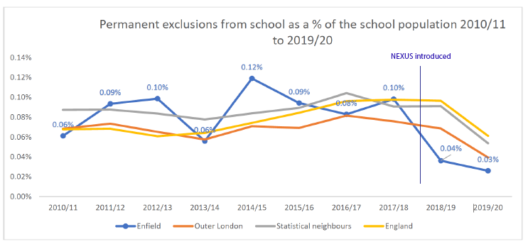

More for Less
NEXUS has delivered an average cost saving for the Council of £242k per annum. This statement is based on a direct comparison between the number of young people that were permanently excluded in the three years preceding the launch of NEXUS (2015/16 – 2017/18) and the two years since (2018/19 & 2019/20). The current cost of a Pupil Referral Unit place is £22,359 with an additional cost of £17,289, and in the three years preceding the introduction of NEXUS, the council spent on average an additional £617k per annum on Pupil Referral Unit places. Whereas, a saving of approximately £242k has been secured for each year the project has been in operation.

The NEXUS Brand has become a trusted mark of quality in the community and schools. Our goal to reduce exclusions and connect the community for a safer Enfield is our constant motivation. The results show that the collaborative work we have been doing is having a positive impact. The feedback our project has received has been encouraging, one young person said “They showed me that no matter what comes your way, your future can always be bright.”, as well as MP Sarah Jones who discusses our project in this video: https://twitter.com/laboursj/status/1451445013838245904.

Further information can be found on our website: https://www.nexusenfield.com/.

